Beekeeping Questionnaire 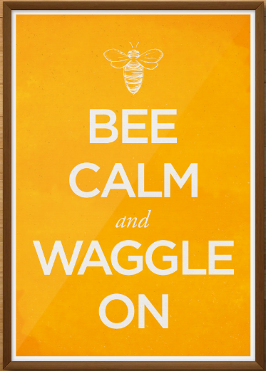

Please answer as few or as many questions as you wish to share. That’s it!
If you wish setup a more personal interview or to take more time to fill out the questionnaire and return it later feel free to contact me at bsteinhauser.sci@gmail.com

- Do you have a degree or any education related to the subject of bees, pollinators, agriculture, entomology, etc...?

- Approximately how much time did you put into researching bees and beekeeping before you got started?

- What stressors are you aware of that are currently affecting bees?

- How long have you been practicing beekeeping, and do you do it for environmental benefits, financial gain, hobby, or other (list)?

- What was the approximate cost to get started and to maintain a bee colony?

- How often do you maintain your hives, or what does a typical week of beekeeping tasks entail in terms of time?

- Did you establish any specific plants, crops or gardens near your hives or place the hives near them? If so, please describe which plant species you used.

- How often to you supplement food for your colony (seasonally, as needed, etc.)?

- What were some drawbacks or problems that you encountered when first establishing the colony?

- If you have experienced Winter loss do you investigate why? If so, list the reason.

- What products or methods do you use for Varroa protection first and then treatment if
needed?

- What other diseases or pests do you protect against?

- Are there many local rules and regulations to follow?

- Do you utilize both the honey and wax? What types of ways do you utilize it?

- Are there any books, articles, or videos that have been vital for your success in beekeeping?

- What motivated you to start beekeeping and why is it important to you?

- If you had to pick one book, article, or video that you hope would motivate another person to care about bees and what is happening to them what would it be?

- Do you eat honey on everything?! I know I do

