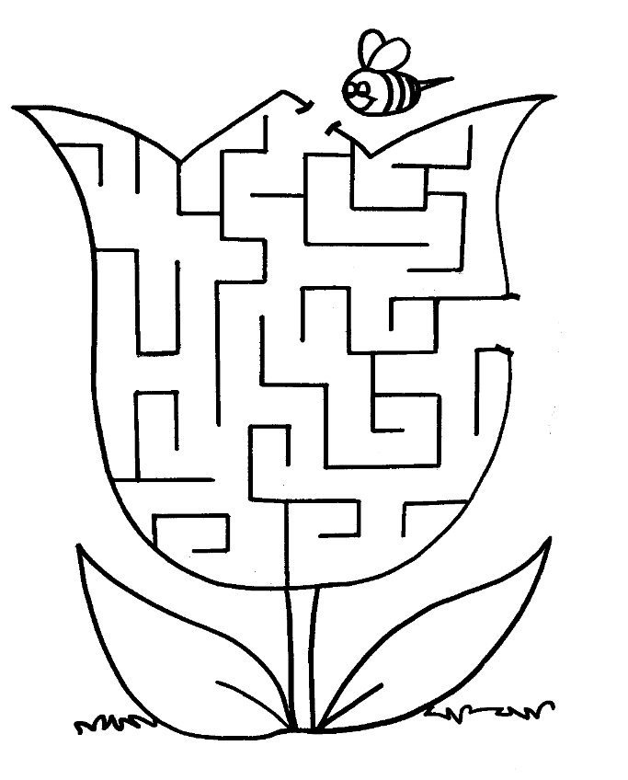

Name__________________________________________

Complete the sentences using the word bank below and Color the Bee on the back (one word is used twice)

Bees have __________ legs

Bees have __________ antennae

Bees have __________ wings

Bees gather ___________from flower, fruit, vegetable, and nut plants

Bees make_____________

Bees live inside a ___________

The ___________ bee is the heart of the colony and makes all the eggs

The ___________ bees gather the food

A bee has ________ main stages of its life cycle

Word Bank
Milk Eight Queen Honey

Hive Worker Baby Six

Pollen Sugar Four House

One Boy King Two
