**Soft Introduction of Forensic Entomology to Younger Students**

A Teacher’s Guide for 4th or 5th grade science

**Science Standards and Crosscutting Concepts (**based on the NGSS for California Public Schools Grades 4 & 5)

Planning and Carrying Out Investigations

* Planning and carrying out investigations to answer questions or test solutions to problems in 3–5 builds on K–2 experiences and progresses to include investigations that control variables and provide evidence to support explanations or design solutions.

Constructing Explanations and Designing Solutions

* Use evidence (e.g., measurements, observations, patterns) to construct an explanation.
* Identify the evidence that supports particular points in an explanation.

Scientific Knowledge is Based on Empirical Evidence

* Science findings are based on recognizing patterns.

Scientific Knowledge Assumes an Order and Consistency in Natural Systems

* Science assumes consistent patterns in natural systems.

Mathematics

* Represent and solve problems involving multiplication and division.
* Generate and analyze patterns.
* Analyze patterns and relationships.

Analyzing and Interpreting Data

* Analyze and interpret data to make sense of phenomena using logical reasoning.
* Represent data in graphical displays to reveal patterns that indicate relationships.

Patterns

* Similarities and differences in patterns can be used to sort, classify, and analyze simple rates of change for natural phenomena
* Patterns can be used as evidence to support an explanation.

Structure and Function

* Plants and animals have both internal and external structures that serve various functions in growth, survival, behavior, and reproduction.

Science is a Human Endeavor

* Science affects everyday life.

**Learning Objectives**

* Students will learn about Incomplete and Complete Metamorphosis and the vocabulary and stages of the life cycle of a blow fly.
* Students will learn the vocabulary and anatomy of a maggot.
* Students will learn about basic decomposition. Students will learn about forensic insect succession, major groups of forensically important insects and the field of wildlife forensics.
* Students will learn about the effect of temperature on fly development by learning to calculate Accumulated Degree Hours (ADH).

**Why Forensic Entomology in Elementary School?**

Forensic Science can seem like a very complex topic from the standpoint of an elementary school educator. How does one teach forensic entomology to children? Why should forensic entomology be included in elementary school curriculum?

Forensic entomology is a growing field of science that focuses on the use of insects in crime solving. The now documented “CSI effect” has revealed that students tend to show more interest in insects when taught in the context of forensic science. However, the breadth of information on forensic entomology available to elementary school and middle school teachers is limited due to the graphic nature of the role that insects play in crime scenes. There are, however, ways to incorporate this fascinating and attention-grabbing topic into the classroom at a younger age by eliminating the use of graphic content and focusing on the science and the insects. With an intentional focus on wildlife forensics, it is intended for this topic to be discussed with minimal disturbance to the comfort of children when talking about death. Therefore, the use of humans remains is replaced with animal remains in the context of what happens to an animal when it dies in nature. Keeping in mind that children are very curious and will likely ask questions about death. From a scientific point of view, death is a part of every life cycle in every ecosystem. This is one of the reasons that wildlife forensics is discussed in place of the medico-legal forensics involved with crime scene forensics. None of the lessons or activities require students to look at dead bodies, or even real maggots. This guide provides lessons and activities for teachers of 4th grade and 5th grade science to foster an early interest in both entomology and forensic science. Each lesson builds upon the one before.

**Class time**

1. Life Cycle of a Blow Fly 30 minutes -1 hour
2. Which Fly is Which? 30 minutes -1 hour
3. Catch a Wave of Succession 1-2 hours
4. Blowfly Development and Temperature 1-2 hours
5. Solve a Mystery (assessment) 30 minutes

**Materials Needed**

* Handout pages (masters provided)
* Scissors
* Glue sticks
* Pencils
* Rulers with millimeters
* Calculators
* Blank paper (colored paper may be used)
* Internet Access & equipment to show video clips (optional)

**Lessons & Activities**

Each lesson is combined with an activity to reinforce the lesson. Lessons plans are complete with materials list, learning outcomes, lesson guide and activity guide. Complete lessons are included in the Appendix

* Life Cycle of a Blow Fly
  + Lesson: Students will learn about Incomplete and Complete Metamorphosis and the vocabulary and stages of the life cycle of a blow fly.
  + Activity: Students will create a Blowfly Lice Cycle Poster
* Which Fly is Which?
  + Lesson: Students will learn the vocabulary and anatomy of a maggot.
  + Activity: Forensic entomologists spend a lot of time looking at maggot spiracles to identify flies. In this activity, students will be given a reference page with several fly maggots and spiracles identified as well as a Specimen ID form with two mystery flies. The students will use their list to determine the identification of their mystery flies.
* Catch a Wave of Succession
  + Lesson: Students will learn about basic decomposition. Students will learn about forensic insect succession, major groups of forensically important insects and the field of wildlife forensics.
  + Activity: Students will create a succession poster for the insects that would arrive at a carcass in nature.
* Blowfly Development and Temperature
  + Lesson: Students will learn about the effect of temperature on fly development by learning to calculate Accumulated Degree Hours (ADH).
  + Activity: A guided activity in which students will calculate the Accumulated Degree Hours (ADH) and determine how many days it takes a blow fly to develop at three different temperatures.
* Last Day Roundtable (Assessment)
  + Solve the Mystery: Student assessment with permission to use student notes from the week.

**Master Vocabulary Terms List** (In the order they are presented in lessons)

|  |  |
| --- | --- |
| Term | Meaning |
| Metamorphosis | A change in form during development |
| Incomplete Metamorphosis | Larvae looks like small adult, gets bigger with each stage |
| Complete Metamorphosis | Larvae do not look like adult, each stage is different: egg, larva, pupa and adult |
| Molt | The shedding of the exoskeleton that happens when an insect grows into a new stage of development |
| Larva | The immature stage that hatches out of an egg |
| Pupa | The stage between larva and adult |
| Puparium | A hard case that protects a larva while it transforms into an adult |
| Maggot | The larvae of flies |
| Instar | Name for stages between molts for flies |
| Term | Meaning |
| Forensic Science | A field of science that helps solve mysteries and crimes. |
| Entomology | The scientific study of insects |
| Entomologist | A scientist who specializes in the study of insects. |
| Maggot | The larva stage of a fly |
| Spiracles | Small holes in the body of an insect where air enters the body. |
| Anterior | Towards the front |
| Posterior | Towards the back |
| Term | Meaning |
| Forensic Science | A field of science that helps solve mysteries and crimes. |
| Entomologist | The scientific study of insects |
| Forensic entomologist | An entomologist that helps to solve mysteries and crimes that have insect evidence. |
| Evidence | Clues that help solve mysteries and crimes. Can include fingerprints, hairs and insects found at a mystery or crime scene |
| Decomposition | The breaking down, or rotting, of living things when they die, including animals and plants. |
| Wildlife forensics | A field of science that helps solve mysteries and crimes involving wildlife and domestic animals. They help the special police that help solve animal crimes. |
| Succession | The pattern of insects that arrive at a carcass, including what life stage of the insect is found during which stage of decomposition. |
| Carcass | The body of a dead animal. |
| Carrion | The decaying flesh of animals. |
| Term | Meaning |
| Accumulated Degree Hours | Amount of energy (by feeding) and time needed to develop from one stage to the next. |

**Recommended videos for use in class:**

Complete vs. Incomplete Metamorphosis for kids (1:52)

<https://www.youtube.com/watch?v=HpC7zkQlLw4>

Complete vs. Incomplete Metamorphosis (2:40)

<https://www.youtube.com/watch?v=nuPCu8lHC8I>

What is an entomologist? (short student friendly video) (1:28)

<https://www.youtube.com/watch?v=Q-38ocCB0ss>

**Additional Teacher resources** (note there are minimal resources for the metamorphosis of flies. Allowing student to see other insects with complete metamorphosis with encourage comparative inquiry for this topic.)

Video resources:

Metamorphosis – The Great Transformation (butterflies) (12:41)

<https://www.youtube.com/watch?v=Lm-s168rW4s>

Inspect an insect (short student friendly video)

<https://www.youtube.com/watch?v=3166nK3Gym8>

Facts About Flies – Secret Nature Fly Documentary (49:31)

<https://www.youtube.com/watch?v=7s5JabD-4OU>

Overview of Forensic Entomology

<https://www.youtube.com/watch?v=pAlLkYSEfC4>

What Does a Wildlife Forensics Scientist Do? (25:33) (interview with real wildlife forensic scientist)

<https://www.youtube.com/watch?v=X_mBgkJiUOA>

Solving Crimes Against Animals with Forensic Experts (4:11)

<https://www.youtube.com/watch?v=DaToaxxLjuk>

Website Resources:

Information about the CSI effect and general forensic science information

<https://www.crimemuseum.org/crime-library/forensic-investigation/>

Information about crimes against animals

<https://www.crimemuseum.org/crime-library/environmental-crimes/crimes-against-animals/>

# 

# References

Achieve. (2020, October). *Fourth Grade - Next Generation Science Standards*. Retrieved from Next Generation Science Standards For States, By States: https://www.nextgenscience.org/sites/default/files/4%20combined%20DCI%20standardsf.pdf

Borror, D. J. (2005). *An introduction to the study of insects.* Belmont: Peter Marshall.

Carmichael, L. E. (2017). *Discover Forensic Science.* Minneapolis: Lerner Publications.

Gardner, R. (2008). *Forensic Science Projects with a Crime Lab You Can Build.* Berkeley Heights: Enslow Publishers Inc.

Haack, J., Harris, D., Makrodimitri, M. C., Monte, M., & Seelman, G. (2016, March 07). *Visible Proofs: Forensic Views of the Body*. Retrieved from National Library of Medicine: https://www.nlm.nih.gov/exhibition/visibleproofs/education/entomology/index.html

Jackson, D. M. (2000). *The Wildlife Detectives: How Forensic Scientists Fight Crimes Against Nature.* Boston: Houghton Mifflin Company.

Kaufman, M. A. (2011, September). *Creature Feature: common green bottle fly*. Retrieved from University of Florida: http://entnemdept.ufl.edu/creatures/livestock/flies/lucilia_sericata.htm

Perritano, J. (2011). *Science Beats Crime.* New York: Marshall Cavendish Benchmark.

Staff. (2019, December 1). *Decomposition: fly life cycle and development times*. Retrieved from Australian Museum: https://australian.museum/learn/science/decomposition-fly-life-cycles/

The Life Cycle of a Blow Fly Diagram. (n.d.). *Student Document*. Michigan State University: Department of Entomology. Retrieved from http://misshalligan.weebly.com/uploads/2/4/8/0/24807467/3222226_orig.jpg

**Appendix**

**The Life Cycle of a Blow Fly**

Materials:

* Blank paper (colored paper may be used)
* Pencils
* Glue sticks
* Scissors
* Rulers with millimeters
* Blow Fly Life Cycle Diagram (handout)
* Blow fly Life Cycle (Cutouts handout)

Learning Objectives:

Students will learn about Incomplete and Complete Metamorphosis.

Students will learn the vocabulary and stages of the life cycle of a blow fly.

Lesson:

Review vocabulary terms.

|  |  |
| --- | --- |
| Term | Meaning |
| Metamorphosis | A change in form during development |
| Incomplete Metamorphosis | Larvae looks like small adult, gets bigger with each stage |
| Complete Metamorphosis | Larvae do not look like adult, each stage is different: egg, larva, pupa and adult |
| Molt | The shedding of the exoskeleton that happens when an insect grows into a new stage of development |
| Larva | The immature stage that hatches out of an egg |
| Pupa | The stage between larva and adult |
| Puparium | A hard case that protects a larva while it transforms into an adult |
| Maggot | The larvae of flies |
| Instar | Name for stages between molts for flies |

**Metamorphosis**

If students are familiar with incomplete and complete metamorphosis:

Review the differences between the two types of metamorphosis and ask the students to name the stages of complete metamorphosis for any insect.

If students are not familiar with incomplete and complete metamorphosis:

Insects are arthropods. Arthropods are animals with jointed legs and an exoskeleton. Can anyone tell me what an exoskeleton is? (Allow for answers) That’s right, an exoskeleton is a skeleton that is worn on the outside. Insects wear their bones on the outside. Some insects have very pretty skeletons! Now when a human grows, our hard bones grow on the inside with a bunch of soft muscle and skin around them. Insects, however, have their soft parts on the inside of a hard skeleton. This makes it hard to grow. Insects and other arthropods have solved this problem with a special way of growing called molting. When an insect is ready to grow, they start making a new exoskeleton underneath the old one. When the soft new exoskeleton is ready, the insect molts or sheds its old exoskeleton and the new one gets hard after the molt. This is kind of like snakeskin shedding but instead of skin, its exoskeleton. As an insect develops, their exoskeleton is shed to allow the insect to get bigger and, in some cases, to help the insect change form. Metamorphosis is the scientific word for a change in form during development. Insects have two types of metamorphosis, incomplete and complete.

Now some insects, like grasshoppers, have incomplete metamorphosis. This means that when the baby grasshopper hatches from its egg, it looks like a small grasshopper. We call these immature insects nymphs. Each time it molts, the nymph becomes a little bit bigger until it is an adult.

Many insects, however, go through complete metamorphosis, like beetles and butterflies and flies. When an insect has complete metamorphosis, the baby that hatches out of the egg does not look like the adult insect that it will grow into. The insect baby that hatches out of the egg is called a larva. Some larvae have special names. Can anyone tell me what the larva of a butterfly is called? (answer is caterpillar) Can anyone tell me what a beetle larva is called? (answer is grub) The larvae of insects with complete metamorphosis grow by molting a certain number of times, each time becoming a larger larva. Once a larva has eaten enough food, it is ready to become an adult. Larvae that are ready to become adults make a pupa. A pupa is a hard case, kind of like an eggshell, that protects the larvae as it transforms into an adult insect with eyes, legs and wings. So the stages of complete metamorphosis are egg, larva, pupa and adult.

Activity:

Today we are going to learn about the life cycle of a blowfly and the special words used for their larva.

* Blow Fly Life Cycle Diagram

Everyone has a handout in front of them with the life cycle of a blowfly. Let’s go over each of the stages and what they are called.

Key:

1. Egg: Fly eggs are small, about 2mm in length.
2. 1st instar maggot: Flies have three maggot stages called instars. The first instar is very small.
3. 2nd instar maggot: After molting, the second instar maggot feeds and feeds.
4. 3rd instar maggot: After molting, the third instar maggot feeds s lot and grows a lot until it has grown enough, then it stops feeding and finds a place to hide and prepare for the next stage.
5. Pupa: The pupa is a protective case. Inside the pupa the body of the maggot turns into something like soup. The maggot soup then starts to form eyes, legs and wings as well as a soft exoskeleton.
6. Adult fly: Once the adult fly emerges from the pupa its exoskeleton will harden and it will be able to fly.

Now I would like everyone to take a handout with the stages of the blow fly lifecycle, a blank sheet of paper, a pair of scissors and a glue stick.

* Blow fly Life Cycle (Cutouts handout)

I would like you to make and label a blowfly life cycle. You can cut out the stages and place them in order on your paper. Use arrows or numbers to show the order of the stages. When you are done, you will keep the poster you made but please return the *Blow Fly Life Cycle Diagram* page.

**Blowfly Life Cycle**

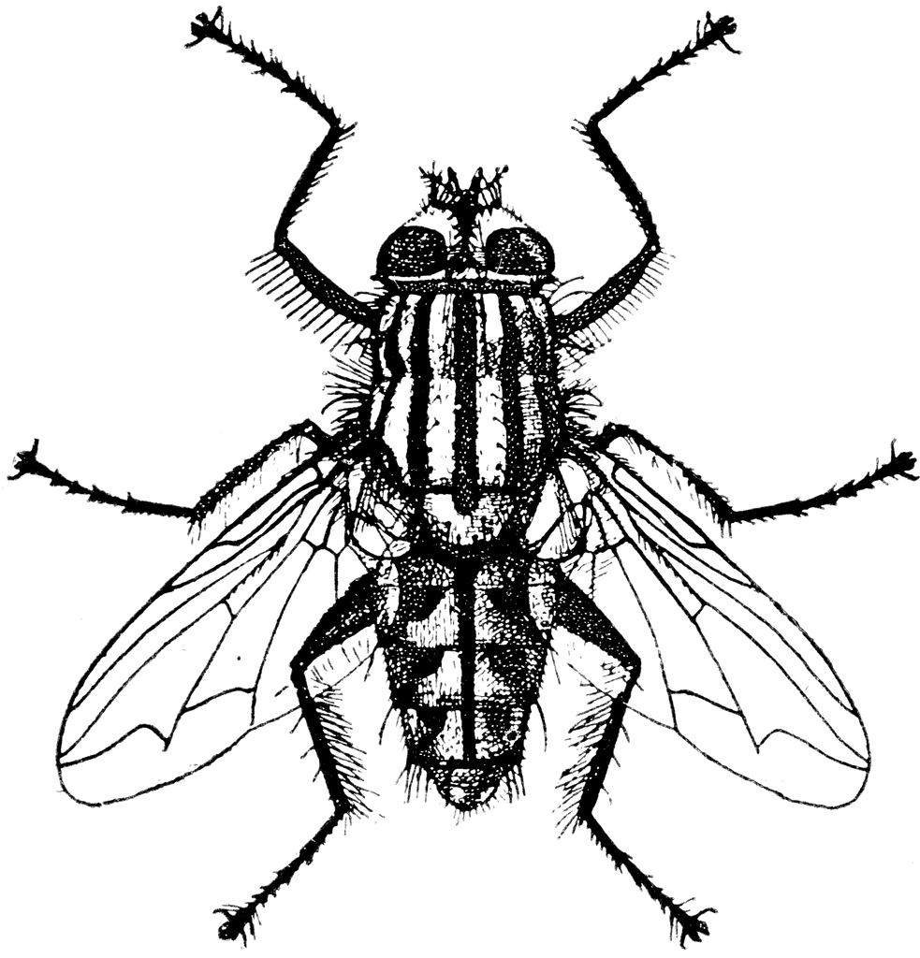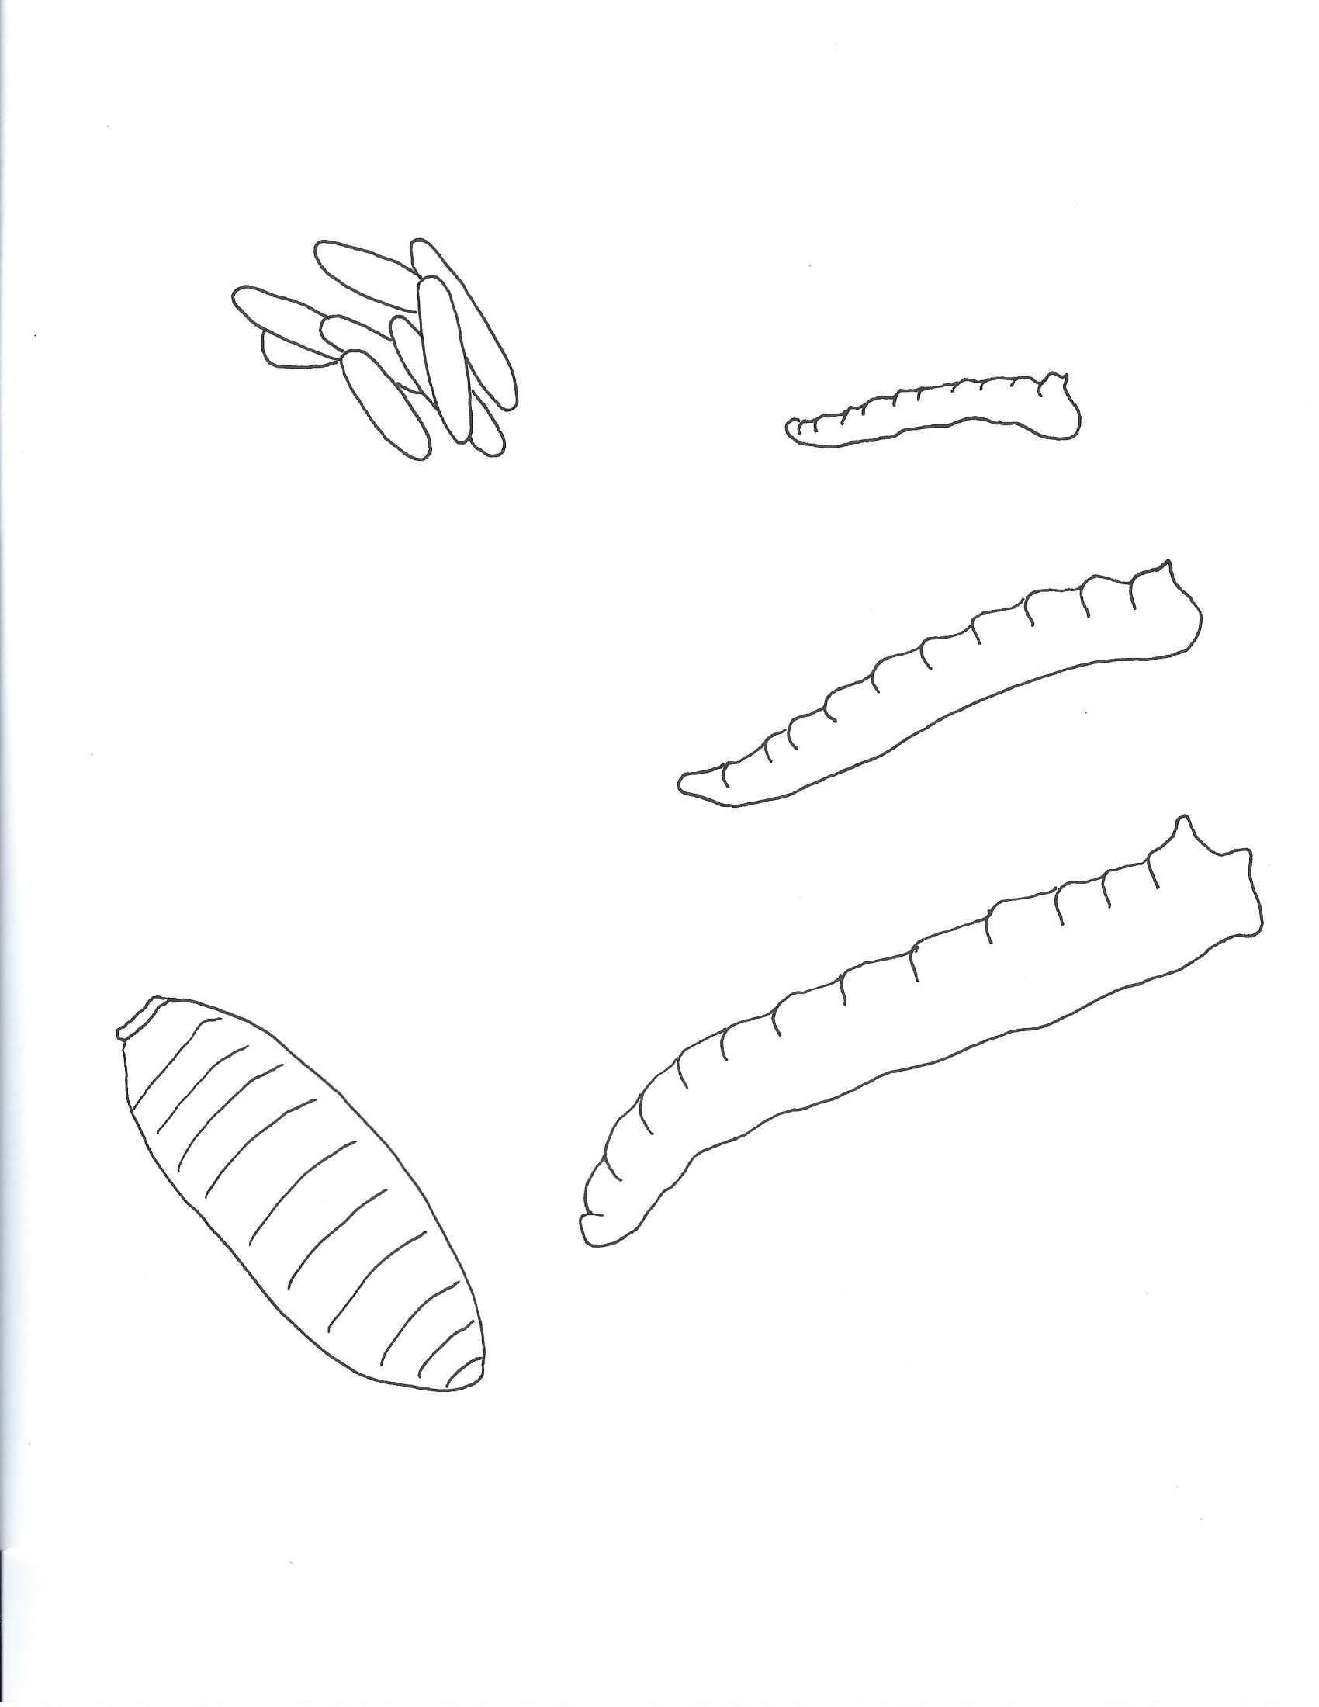

Key:

1. Egg
2. 1st instar maggot
3. 2nd instar maggot
4. 3rd instar maggot
5. Pupa
6. Adult fly

6

5

4

1

3

2

**Blowfly Life Cycle Cut-outs**

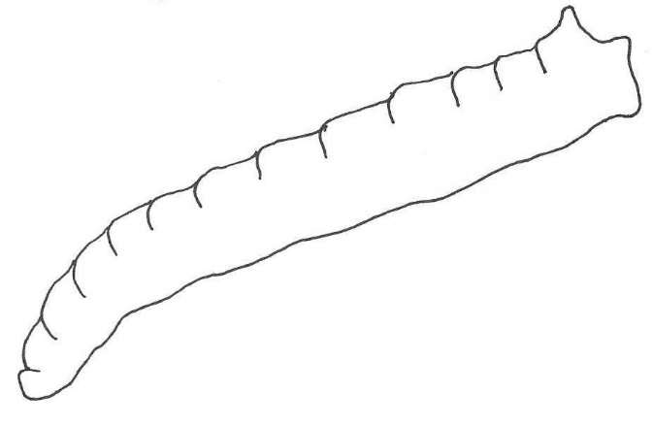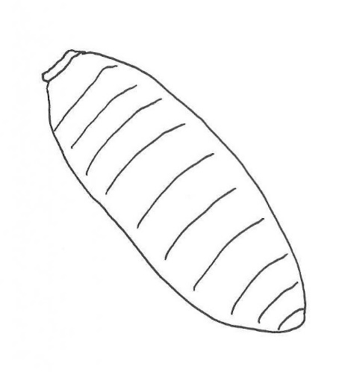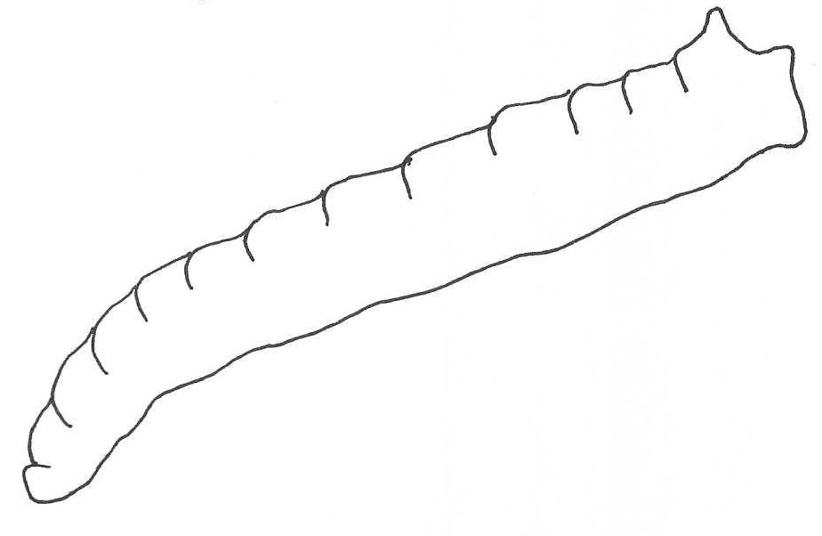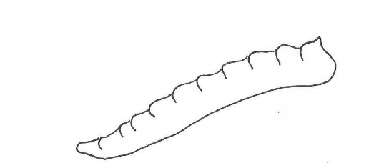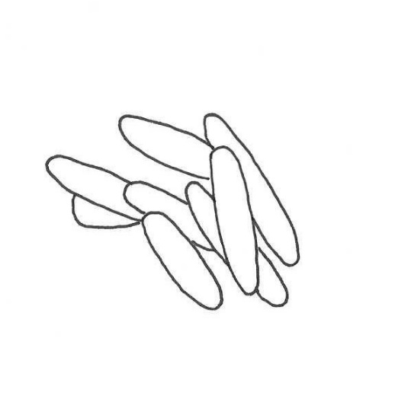

**Which Fly is Which?**

Materials:

* Pencils
* Parts of a Maggot (handout)
* Fly Identification Sheet (handout)
* Specimen ID form (6 different versions of handout)

Learning Objectives:

Students will learn the vocabulary and anatomy of a maggot.

Lesson:

Review Vocabulary Terms:

|  |  |
| --- | --- |
| Term | Meaning |
| Forensic Science | A field of science that helps solve mysteries and crimes. |
| Entomology | The scientific study of insects |
| Entomologist | A scientist who specializes in the study of insects. |
| Maggot | The larva stage of a fly |
| Spiracles | Small holes in the body of an insect where air enters the body. |
| Anterior | Towards the front |
| Posterior | Towards the back |

Let’s learn the anatomy of a maggot.

* Parts of a Maggot (handout)

The body of a maggot is simple on the outside. There are no legs or eyes. There are small hooks in the mouth to help hold onto food. There are two sets of spiracles. What are spiracles? Well insects breathe air like we do, but they do not have lungs. They have tubes that go throughout their bodies bringing air to the cells and tissues that need it. The tubes are connected to little holes called spiracles. These are kind of like nostrils, but on the body not the face. Spiracles are located on the thorax and abdomen of most insects. Flies have two sets of spiracles, anterior or front spiracles and posterior or back spiracles. If you look at the maggot on your sheet, you will see the anterior and posterior spiracles marked. The anterior spiracles look like little hands. The posterior spiracles are located in the very back of the maggot and these are the spiracles that tell us which fly the maggot will grow into. Why do you think a maggot would have breathing holes on its rear end? (This might not be obvious to students.) Maggots feed on liquids and often in crowded groups called maggot masses. They often have their entire head in liquid, so they evolved breathing holes on their rear end so they don’t have to stop feeding to breathe.

If you look at the page called *Maggot Instars and Spiracle Numbers*, you will see that as a maggot develops and molts, the number ovals in the posterior spiracles get higher. One for each instar.

**Activity:**

Today you are going to be the entomologist working in a wildlife forensic lab. You arrived at work to find several specimens on your desk waiting to be identified. You grab your fly identification sheet set out to identify the specimens.

* Fly Identification Sheet (handout)
* Specimen ID form (6 different versions of handout)

Fly identification sheets are made by entomologists to help in identification of maggots found at crime scenes. As you can see this sheet will help you identify your specimens. Each of you will have two specimens to identify. Fill out your specimen ID form and don’t forget to put your name on it.

**Parts of a Maggot**

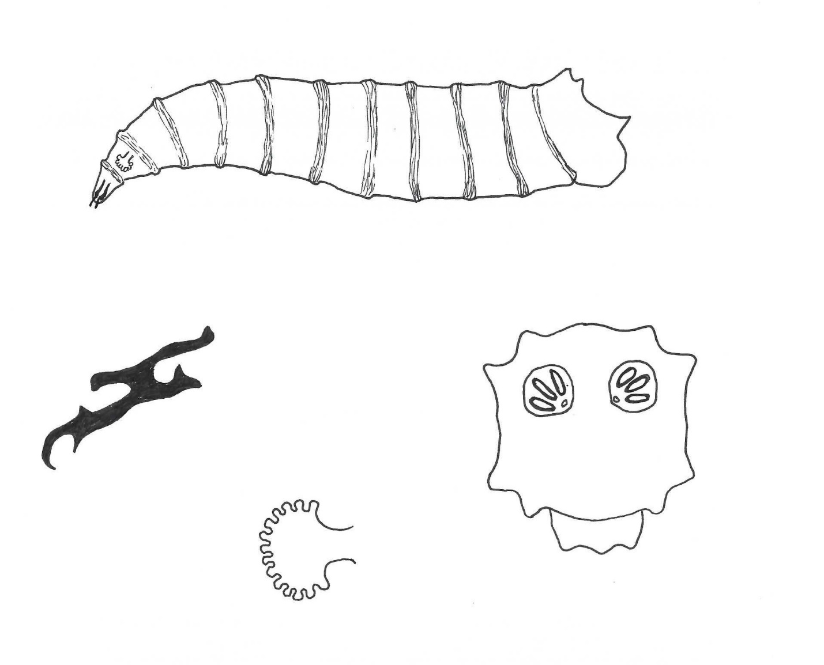

**Posterior spiracles**: these are the back set of spiracles. These allow a maggot to breathe when it feeds on liquids. These spiracles have a special shape for each fly, so they are used to identify maggots.

**Anterior Spiracles**: these are the front set of spiracles, they are important when the fly is an adult.

**Mouth hooks**: The maggot uses these to grab ahold of what it is feeding on.

**Maggot Instars and Spiracle Numbers**

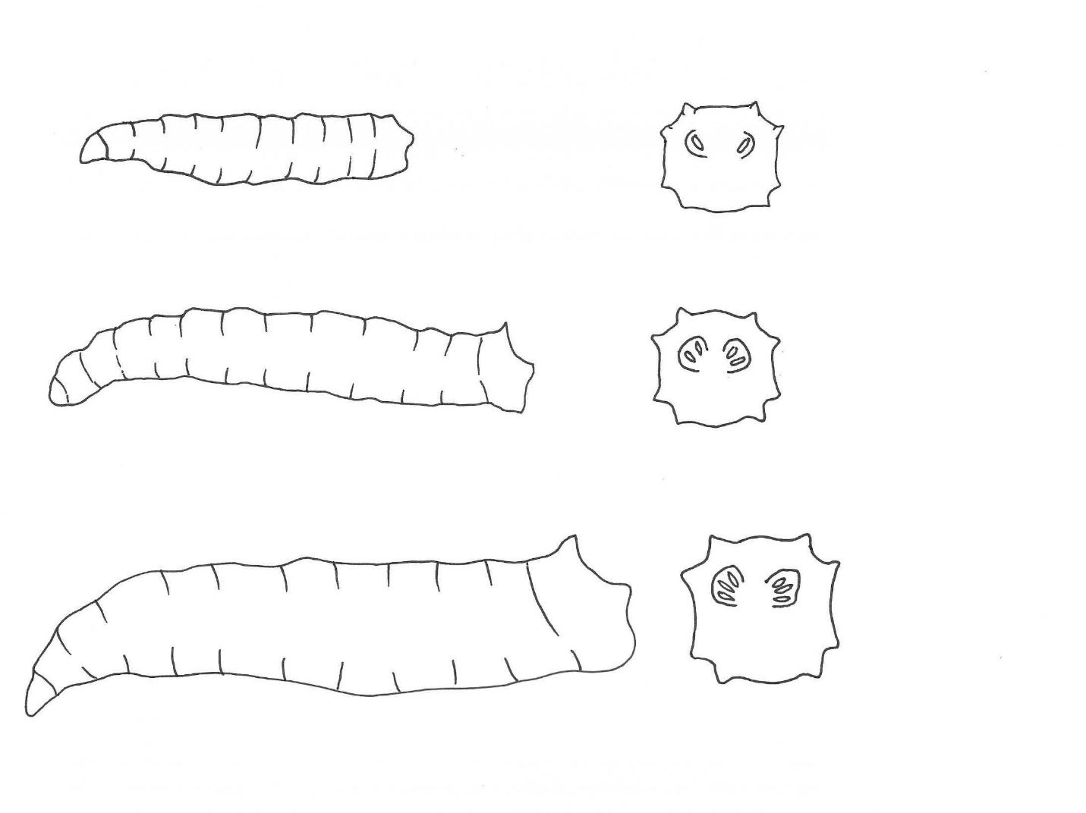

1st instar maggots have one oval in their spiracles.

3rd instar maggots have three ovals in their spiracles.

2nd instar maggots have two ovals in their spiracles.

**Fly Identification Sheet**

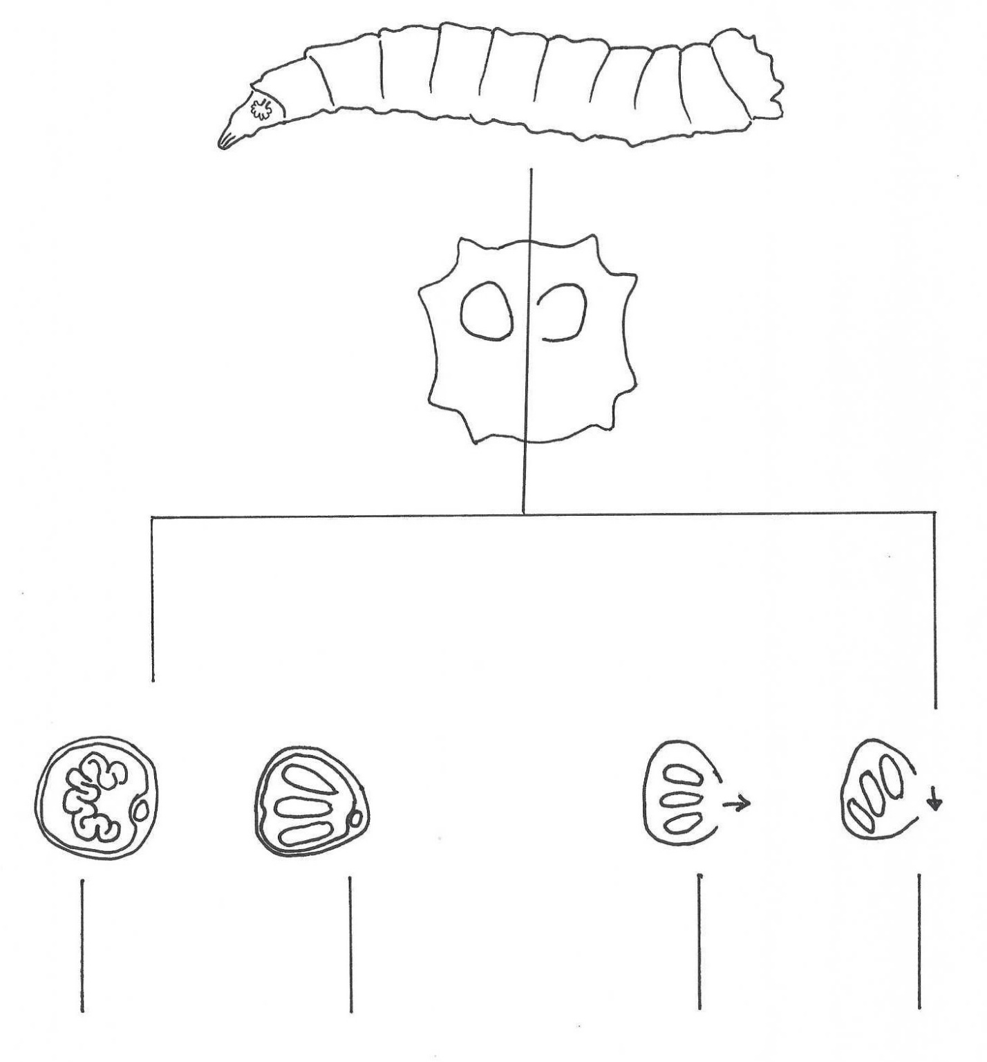

**Blow Fly**

The blow fly has three ovals

**House Fly**

the house fly has wiggles

**Black Fly**

The black fly ovals point to the side

**Flesh Fly**

The flesh fly ovals point down

Open spiracles

Closed spiracles

**Specimen ID Form**

Name: _________________________ Date: _________________________

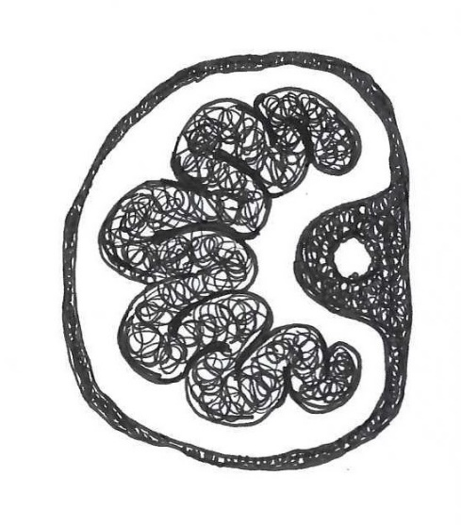 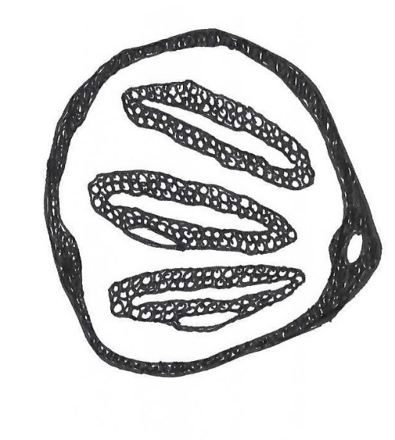

Specimen 1: ______________________ Specimen 2: _____________________________

Cut here - - - - - - - - - - - - - - - - - - - - - - - - - - - - - - - - - - - - - - - - - - - - - - - - - - - - - - - - - - - - - - - - - - - - - -

**Specimen ID Form**

Name: _________________________ Date: _________________________

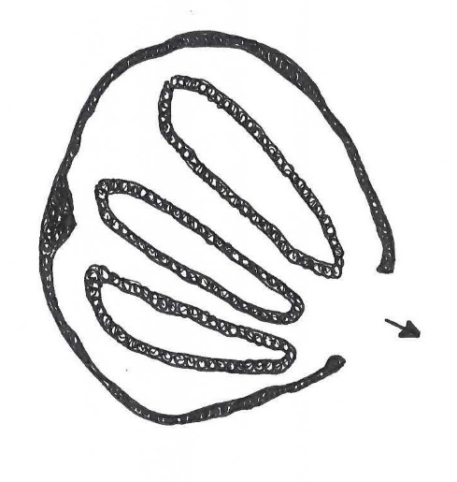 

Specimen 1: ______________________ Specimen 2: _____________________________

**Specimen ID Form**

Name: _________________________ Date: _________________________

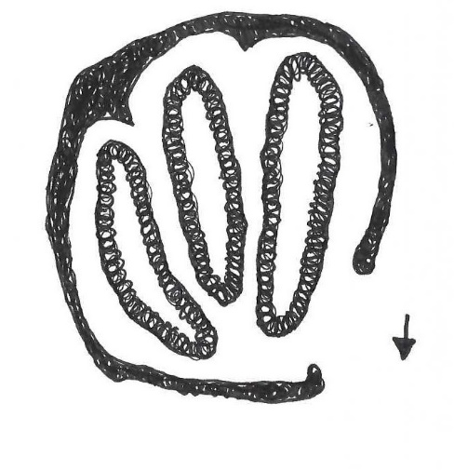 

Specimen 1: ______________________ Specimen 2: _____________________________

Cut here - - - - - - - - - - - - - - - - - - - - - - - - - - - - - - - - - - - - - - - - - - - - - - - - - - - - - - - - - - - - - - - - - - - - - -

**Specimen ID Form**

Name: _________________________ Date: _________________________

 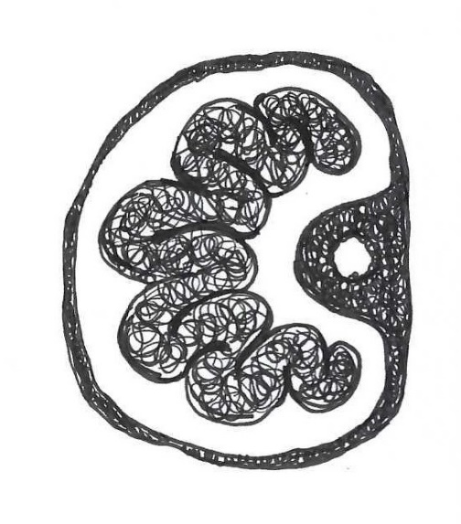

Specimen 1: ______________________ Specimen 2: _____________________________

**Specimen ID Form**

Name: _________________________ Date: _________________________

 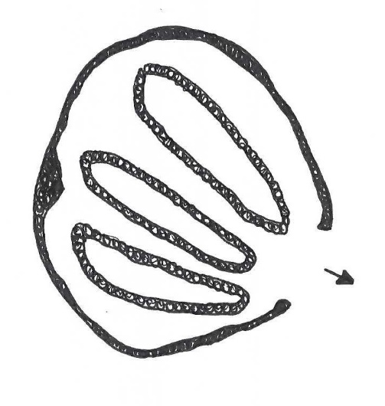

Specimen 1: ______________________ Specimen 2: _____________________________

Cut here - - - - - - - - - - - - - - - - - - - - - - - - - - - - - - - - - - - - - - - - - - - - - - - - - - - - - - - - - - - - - - - - - - - - - -

**Specimen ID Form**

Name: _________________________ Date: _________________________

 

Specimen 1: ______________________ Specimen 2: _____________________________

**Catch a Wave of Succession**

Materials:

* Blank paper (colored paper may be used)
* Pencils
* Glue sticks
* Scissors
* Forensically Important Insect Picture Guide (handout)
* Catch a Wave of Succession Poster (handout)
* Forensically Important Insects (cutout handout)

Learning Objectives:

Students will learn about basic decomposition. Students will learn about forensic insect succession, major groups of forensically important insects and the field of wildlife forensics.

Lesson:

Review new vocabulary words.

|  |  |
| --- | --- |
| Term | Meaning |
| Forensic Science | A field of science that helps solve mysteries and crimes. |
| Entomologist | The scientific study of insects |
| Forensic entomologist | An entomologist that helps to solve mysteries and crimes that have insect evidence. |
| Evidence | Clues that help solve mysteries and crimes. Can include fingerprints, hairs and insects found at a mystery or crime scene |
| Decomposition | The breaking down, or rotting, of living things when they die, including animals and plants. |
| Wildlife forensics | A field of science that helps solve mysteries and crimes involving wildlife and domestic animals. They help the special police that help solve animal crimes. |
| Succession | The pattern of insects that arrive at a carcass, including what life stage of the insect is found during which stage of decomposition. |
| Carcass | The body of a dead animal. |
| Carrion | The decaying flesh of animals. |

Have you ever wondered what happens to an animal when it dies out in nature? Have you heard of decomposers? What are some things a decomposer might feed on? (wait for multiple answers. Some correct answers include garbage and dead bodies)

There is a special field of forensic science called wildlife forensics and it focuses on crimes involving wildlife and domestic animals. What is an example of a domestic animal? (wait for answers) What are some examples of wildlife? (wait for answers). The entomologists that work in wildlife forensics help solve mysteries and crimes involving dead animals. Before these entomologists start working in the field, they must learn some important things about what happens to an animal when it dies out in nature. One of the first things these entomologists learn about is forensic insect succession.

When an animal dies in nature there are several decomposers that show up and recycle the animal carcass while they feed and make babies. The forensic entomologist learns that there are certain groups of insects that show up to a carcass, and they show up in a certain order as the carcass decomposes.

* Forensically Important Insect Picture Guide (handout)

So, let’s talk about the forensically important insects that show up to an animal carcass, when they show up and why they show up at that time. The insects show up in what entomologists call waves of succession. (pass out *Forensically Important Insect Picture Guide*) There are two major groups of insects that arrive at a carcass, flies and beetles.

Flies are from the insect order Diptera which means two wings. Flies are different from other flying insects because they only have two wings while other flying insects such as bees have four wings. Adult flies drink their food, so when they show up to a carcass, they look for liquids such as blood. But it’s not the feeding that makes the flies important, it’s what they do after they feed. Flies lay their eggs on a carcass because their babies, called maggots, eat the liquids and flesh of dead bodies. It sounds gross, but it is a great service provided by maggots. Can you imagine how many stinky things would be laying around if maggots didn’t eat them up? So, before she leaves a carcass, a female fly will deposit up to 300 eggs. The first flies that show up to a carcass can smell it minutes after it dies. This is called the fresh stage and the first wave of insects begins with blow flies. Shortly after the blow flies show up and while the carcass is still fresh, house flies and flesh flies may arrive. As the fresh stage ends, the carcass begins to decompose and it begins to smell. As the first stage changes into the second stage, flesh flies arrive to the carcass. Now that the carcass is smelly and has lots of maggots feeding ad growing on it, it’s time for the beetles to arrive. The second wave of insects include rove beetles and carrion beetles. During this second wave, some of the maggots are ready to leave the carcass and go make a pupa to change into an adult fly. Some beetles that arrive will find and eat maggots at night and hide under the carcass during the day. Others like the carrion beetles will feed upon the flesh or lay their eggs on the dead animal and their larvae will feed on the flesh. So once the beetles show up, the number of maggots begins to drop. As the maggots start to leave, the decomposition stage comes closer to an end. Checkered beetles show up as the decomposition stage is ending and the dry stage begins. The last beetles to show up are the dermestid beetles who feed on any hairs and dry skin that might be left. This is the end of the decomposition stages and the end of insect succession waves.

It's important to know that some of these insects may overlap in when they arrive, so this is just a basic successive pattern.

1st wave: Blow flies, house flies, flesh flies

2nd wave: Flesh flies, rove beetles, carrion beetles, checkered beetles

3rd wave: Checkered beetles, dermestid beetles.

|  |  |  |
| --- | --- | --- |
| 1st wave: Fresh | 2nd wave: Decomposing | 3rd wave: Dry bones |
| Blowflies  Flesh flies  Houseflies | Rove Beetles  Checkered Beetles  Carrion Beetles | Dermestid Beetles |

Activity:

Now we are going to create a Forensic Insect Succession Poster. We will start by cutting out our insects. Cut around each insect in an oval like shape so you get all the parts of the insect. Now let’s place our insects as they would arrive at the animal carcass.

1. The first wave of insects begins with blow flies. Find your blow fly and glue it in the first wave section of your poster.
2. Next to arrive in the first wave are the house flies. Catch your house fly and glue it under the blow flies in the first wave section of your poster.
3. Now our next fly, the flesh fly, will show up during the time when the first wave is changing to the second wave. Find your flesh fly and glue it on the line that separates the first and second waves.
4. Now our beetles. The first beetles to show up are the rove beetles. Find your rove beetle and glue it to the second wave section of your poster.
5. Carrion beetles arrive next. Carrion is one of our vocabulary terms. Can someone tell me what carrion is? (wait for answer) Find your carrion beetle and glue it to the second wave section of your poster.
6. Our next beetle, the Checkered beetle, is like the flesh fly because it arrives when a stage change is happening. Find your checkered beetle and glue it on the line that separates the second and third waves.
7. We have one beetle left, the dermestid beetle. This beetle like the last dry bits left after decomposition, so it is the last beetle to arrive. Glue your dermestid beetle to the third wave section of your poster.

**Forensically Important Insect Picture Guide**

The flies (Order: Diptera)

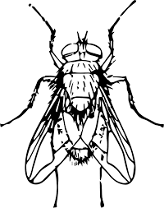 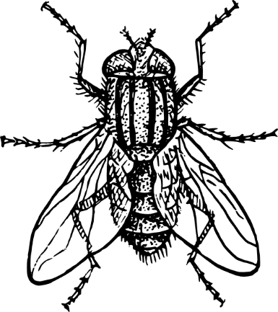 

|  |  |  |
| --- | --- | --- |
| Blow fly | House fly | Flesh fly |
| * Metallic green, blue or copper * First to arrive | * Gray and black with red eyes * 4 black stripes on thorax | * Gray and black with red eyes * 3 black stripes on thorax |

The beetles (Order: Coleoptera)

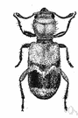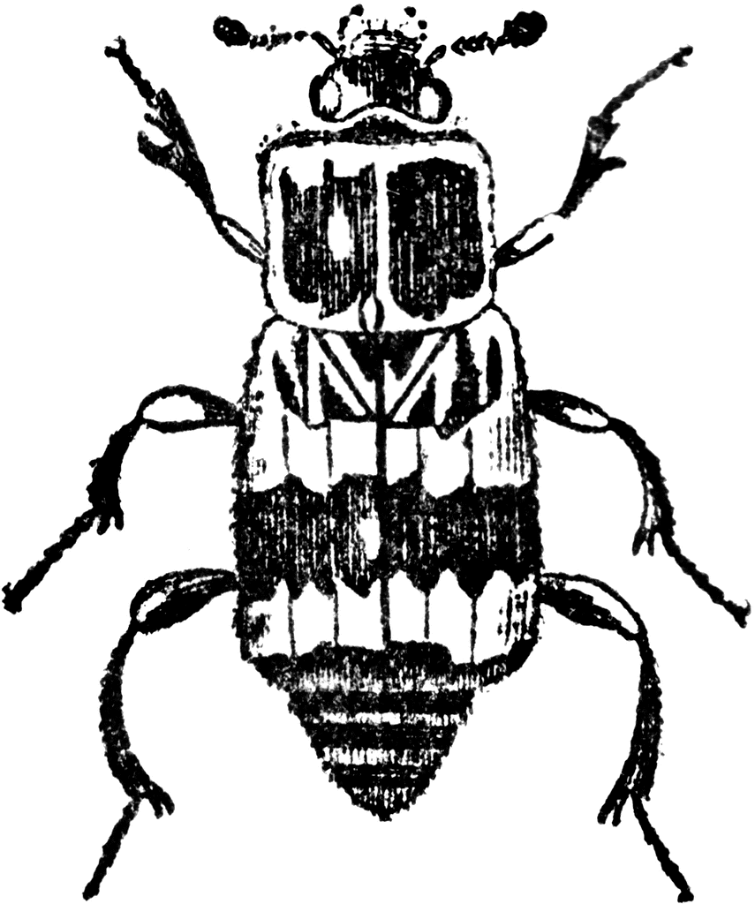

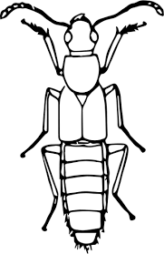

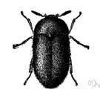

|  |  |  |  |
| --- | --- | --- | --- |
| Rove Beetle | Carrion Beetle | Checkered Beetle | Dermestid Beetle |
| * Small, no hair * Black, sometimes with red | * Large, little hair * Black and red | * Medium, some hair * Black and orange or red | * Small, hairy * Brown |

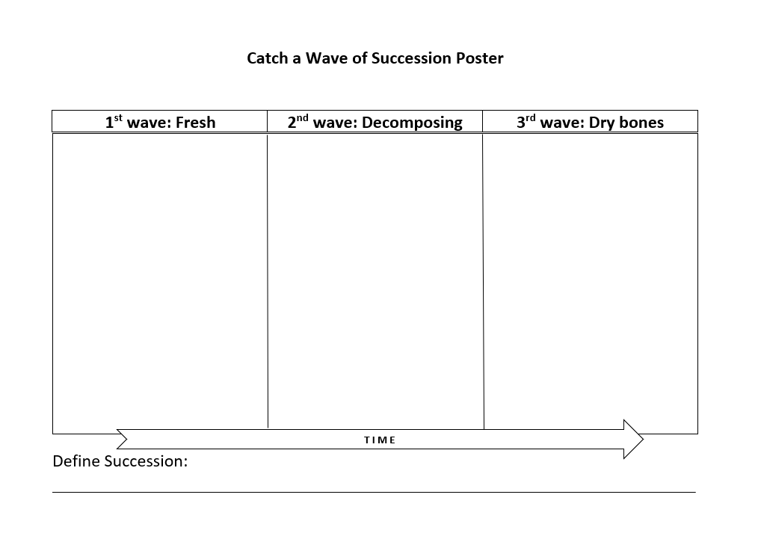

**Forensically Important Insects Cutouts**

 

 



**Blow fly Development and Temperature**

Materials:

* Blow Fly Development and Temperature Data for the Green Bottle Blow Fly (handout)
* Calculators
* Pencils
* Scratch paper

Learning Objectives:

Students will learn about the effect of temperature on fly development by learning to calculate Accumulated Degree Hours.

Lesson:

Review Vocabulary Terms:

|  |  |
| --- | --- |
| Term | Meaning |
| Accumulated Degree Hours | Amount of energy (by feeding) and time needed to develop from one stage to the next. |

This will be a combined Lesson/activity that is done as a group. Students will need to have the *Blow Fly Life Cycle Poster* that they made to use for reference.

Activity:

(This activity is designed to encourage student participation)

We are going to use some math and our knowledge of the blow fly life cycle to determine how long it takes a blow fly to grow from egg to adult.

* Blow fly Development and Temperature Data for the Green Bottle Blow fly
* Calculators

Review life cycle of blow fly. Have student use their Blow fly Life Cycle Poster for reference. Go over the stages of maggot development and the life cycle of the blow fly.

So, we are going to take a closer look at the life cycle of a blow fly. Let’s discuss each stage of development and what is happening.

If you look at your handout. Who can tell me about the egg stage? (discuss)

Repeat with each stage before beginning activity.

Have students look at the data for the Development Time in hours. Note that we have data for three different temperatures in Celsius. So, the first thing we will do is convert the temperatures in Celsius to Fahrenheit.

We will use this formula: (degrees Celsius X 9/5) + 32 = degrees in Fahrenheit.

We are going to use this data to calculate the **Accumulated Degree Hours,** which is a fancy way to say *how much time a maggot has to eat to develop from egg to adult*.

Now that you have the temperature in ° F, you can calculate the Accumulated Degree Hours (ADH). Fill in the tables with the temperature in ° F, the hours from the data above and then calculate your ADH hours with multiplication. Add up your TOTAL HOURS (not the ADH) and use the total to find out how many days it takes a blow fly to grow from egg to adult. You will repeat this for each temperature while filling out your handout.

(assist with questions while the students are filling out their worksheets.)

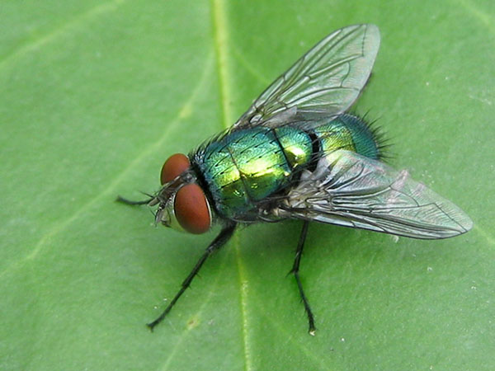**Blow Fly Development and Temperature Data for**

**The Green Bottle Blow fly (*Lucilia sericata*)**

The data below gives you information about the stages of

development for the Green Bottle Blow Fly. You will be using

this data for your calculations.

Stages of Development, Size, Behavior and Average Time per Stage

|  |  |  |  |  |  |  |  |
| --- | --- | --- | --- | --- | --- | --- | --- |
| Stage | egg | 1st instar | 2nd instar | 3rd instar | Pre-pupa | pupa | adult |
| Size | 1.5 mm | 2-4 mm | 5-10mm | 11-18 mm | 12-18 mm | 9-10 mm | 8-10 mm |
| Behavior & average time | Laid un clusters of up to 300.  Will hatch within 24 hours. | Looks for openings on carcass.  Feeds on fluids.  1 day | Maggot mass forms.  Feeds a lot.  1 day | Maggot mass is very warm.  Feeds a lot.  Grow in size.  2 days | Stops feeding.  Wanders away from carcass.  Begins to make puparium.  4 days | Transforms into an adult: forms eyes, legs and wings.  10 days. | Emerges from puparium.  Can lay eggs in 3 days.  Lives up to one month. |

Development time (in hours) for the Green Bottle Blow Fly at three different temperatures.

|  |  |  |  |  |  |  |  |
| --- | --- | --- | --- | --- | --- | --- | --- |
|  | Temperature | egg | 1st instar | 2nd instar | 3rd instar | Pre-pupa | pupa |
| A | 16° C | 41 | 53 | 42 | 98 | 148 | 393 |
| B | 21° C | 21 | 31 | 26 | 50 | 118 | 246 |
| C | 27° C | 18 | 20 | 12 | 40 | 90 | 168 |

1. Convert the temperatures in Celsius to Fahrenheit. We will use this formula: (degrees Celsius X 9/5) + 32 = degrees in Fahrenheit.

A: (______° C X $\frac{9}{5}$) + 32 = _______ ° F

B: (______° C X $\frac{9}{5}$) + 32 = _______ ° F

C: (______° C X $\frac{9}{5}$) + 32 = _______ ° F

1. Calculate the Accumulated Degree Hours. Use the Temperature in ° F from step one for all three temperatures. Fill in the tables below with the temperature, the hours from the data above and then your ADH hours.

A:

|  |  |  |  |  |  |
| --- | --- | --- | --- | --- | --- |
| Stage | Temperature in ° F | Multiply | Hours from data |  | Accumulated Degree Hours (ADH) |
| Egg to 1st instar |  | **X** |  | = |  |
| 1st instar to 2nd instar |  | **X** |  | = |  |
| 2nd instar to 3rd instar |  | **X** |  | = |  |
| 3rd instar to pupa |  | **X** |  | = |  |
| Pupa to adult |  | **X** |  | = |  |
|  |  |  | Add the ADH hours for total 🡪 |  |  |

_____________ ADH divided by 24 hours = _______________ days ___________ hours.

B:

|  |  |  |  |  |  |
| --- | --- | --- | --- | --- | --- |
| Stage | Temperature in ° F | Multiply | Hours from data |  | Accumulated Degree Hours (ADH) |
| Egg to 1st instar |  | **X** |  | = |  |
| 1st instar to 2nd instar |  | **X** |  | = |  |
| 2nd instar to 3rd instar |  | **X** |  | = |  |
| 3rd instar to pupa |  | **X** |  | = |  |
| Pupa to adult |  | **X** |  | = |  |
|  |  |  | Add the ADH hours for total 🡪 |  |  |

_____________ ADH divided by 24 hours = _______________ days___________ hours

C:

|  |  |  |  |  |  |
| --- | --- | --- | --- | --- | --- |
| Stage | Temperature in ° F | Multiply | Hours from data |  | Accumulated Degree Hours (ADH) |
| Egg to 1st instar |  | **X** |  | = |  |
| 1st instar to 2nd instar |  | **X** |  | = |  |
| 2nd instar to 3rd instar |  | **X** |  | = |  |
| 3rd instar to pupa |  | **X** |  | = |  |
| Pupa to adult |  | **X** |  | = |  |
|  |  |  | Add the ADH hours for total 🡪 |  |  |

_____________ ADH divided by 24 hours = _______________ days___________ hours.

1. Define Accumulated Degree hours ______________________________________________________________________________________________________________________________________________________________________________________________________________________________

4. Fill in the following using your calculations.

It takes __________ days ______ hours for a Green Bottle Blow Fly to grow from an egg to an adult at ________° F

It takes __________ days ______ hours for a Green Bottle Blow Fly to grow from an egg to an adult at ________° F

It takes __________ days ______ hours for a Green Bottle Blow Fly to grow from an egg to an adult at ________° F

**Solve the Mystery**

You are the forensic entomologist in a wildlife forensics lab. Today detectives came to your lab with some clues. They would like you to help them identify the clues. Answer the following questions to help the detectives solve their case.

1) The detectives found these at the crime scene. What are these?

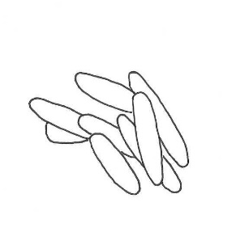 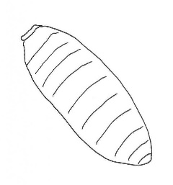 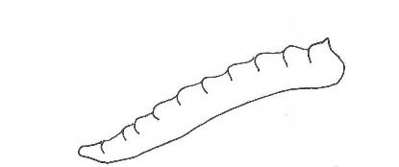

________________ _____________________ _____________________

What animal do these belong to? ____________________

What kind of metamorphosis does this animal have? _____________________________

2) The detectives took pictures of an insect that they found at the crime scene. Can you tell them what kind of insect it is?



What stage of decomposition is the carcass if this insect was found? ___________________________________

____________________

3) The detectives took the temperature at the crime scene. The temperature is 21° C. The detectives give you a Green Bottle Blow Fly maggot that was collected at the crime scene. Can you tell the detectives how much time was needed for the maggot to get to this size?

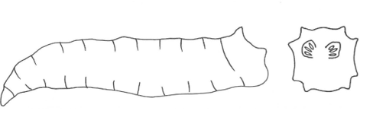

To answer this question, answer these questions first:

1. What stage of development is your maggot? _________________________
2. What is 21° C in ° F? (______° C X $\frac{9}{5}$) + 32 = _______ ° F
3. How many Accumulated Degree Hours does it take for a maggot to grow to this stage? Use the table below. You might not need to use all the squares.

|  |  |  |  |  |  |
| --- | --- | --- | --- | --- | --- |
| Stage | Temperature in ° F | Multiply | Hours from data |  | Accumulated Degree Hours (ADH) |
| Egg to 1st instar |  | **X** |  | = |  |
| 1st instar to 2nd instar |  | **X** |  | = |  |
| 2nd instar to 3rd instar |  | **X** |  | = |  |
| 3rd instar to pupa |  | **X** |  | = |  |
| Pupa to adult |  | **X** |  | = |  |
|  |  |  | Add the ADH hours for total 🡪 |  |  |

______________Total Hours divided by 24 hours = _______ days ___________hours

**Key: Solve the Mystery**

You are the forensic entomologist in a wildlife forensics lab. Today detectives came to your lab with some clues. They would like you to help them identify the clues. Answer the following questions to help the detectives solve their case.

1) The detectives found these at the crime scene. What are these?

  

_______EGG_____ ______PUPA________ ______MAGGOT____

What animal do these belong to? ___A FLY____

What kind of metamorphosis does this animal have? _____COMPLETE______

2) The detectives took pictures of an insect that they found at the crime scene. Can you tell them what kind of insect it is?



What stage of decomposition is the carcass if this insect was found? ______DECOMPOSING_________

_____BEETLE____

3) The detectives took the temperature at the crime scene. The temperature is 21° C. The detectives give you a Green Bottle Blow Fly maggot that was collected at the crime scene. Can you tell the detectives how much time was needed for the maggot to get to this size?



To answer this question, answer these questions first:

1. What stage of development is your maggot? ________3RD INSTAR___
2. What is 21° C in ° F? (_21__° C X $\frac{9}{5}$) + 32 = __69.8_____ ° F
3. How many Accumulated Degree Hours does it take for a maggot to grow to this stage? Use the table below. You might not need to use all the squares.

|  |  |  |  |  |  |
| --- | --- | --- | --- | --- | --- |
| Stage | Temperature in ° F | Multiply | Hours from data |  | Accumulated Degree Hours (ADH) |
| Egg to 1st instar | 69.8 | **X** | 21 | = | 1465.8 |
| 1st instar to 2nd instar | 69.8 | **X** | 31 | = | 2163.8 |
| 2nd instar to 3rd instar | 69.8 | **X** | 26 | = | 1814.8 |
| 3rd instar to pupa | 69.8 | **X** | 50 | = | 3490 |
| Pupa to adult | __________ | **X** | ________ | = | _________________ |
| Totals | __________ |  | 128 |  | 8934.4 |

___128_____ Total Hours divided by 24 hours = ______5______ days ____3_____ hours.

You tell the detectives that this fly would need at least ____5___ days to grow this big.