Wanted
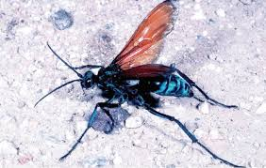
Pepsis grossa
Considered Armed
If seen contact the MIB

Sex: Female
Modus Operandi: Utilizing powerful paralytic venom to subdue its prey, and subsequently ovipositing eggs within the victim, and sealing the body underground, where it will act as a living larder for the parasitoid's offspring

Known Habitats: Northern South America all the way up to the North American southwest. Known to be crepuscular.

