Bug basics  A Quizlet Style Educational Trivia Game | Tell me and I forget. Teach me and I remember. Involve me and I learn. ~ Benjamin Franklin  Glynnys D. Pentecoste  University of Nebraska – Lincoln M.S. in Entomology Program ENTO888 Final Project February 2020

Table of Contents

Overview & Development 2
Assessment & Feedback 3
How to Play 4
Outline & Storyboard 5
References 22
References – Digital Photos 23
Appendix A – Optional Intermediate Level Game Question Bank 28
Appendix B – Optional Advanced Level Game Question Bank 36

Overview & Development

Overview

The goal of this project is to create and develop an augmented reality (AR) game that stimulates an interest in entomology and related ecological concepts. This project seeks to leverage AR technology to combine real-world overlays with virtual, computer-generated enhancements to foster or bolster an interest in insects and their natural habitat(s). Using scavenger hunt and geocaching strategies as the underlying conceptual paradigm, students will navigate a series of challenges to virtually collect a pre-determined number of insect-related items or tokens. Using a trivia- or quizlet-style interface, knowledge of fundamental entomological concepts will be emphasized throughout. Successful navigation and completion of the game will be predicated upon the ability to apply these concepts across a series of entomological vignettes to obtain required items and bypass a prescribed number of levels. The ultimate outcome of this project should be the creation for a fun, educational game that captures and holds user interest via hands-on, technologically-augmented activities that simultaneously foment or enhance an increased appreciation for insects.

Development

In their study on AR applications, Billinghurst, Clark, and Lee (2014) emphasized the positive educational benefits that can be achieved through the deliberate use of AR technology. As they point out, “Results show that AR’s high level of interactivity enhances learning, particularly for students who learn through kinesthetic, visual, and other non-text-based methods” (p. 211). To this end, the use of AR can be leveraged to promote increased understanding of inherently complex or abstract problem sets, increasing conceptualization skills and overall knowledge retention (Billinghurst & Duenser, 2012). The rationale behind developing this particular project rests upon this and related research, as well as an intrinsic personal interest in educational multimedia applications, entomology, and conservation ecology.

The Metaverse Experience application (app) was selected for development for several reasons, including overall cost (free), ease of use (easy), and personalization potential (vast). This particular app is quite popular among elementary teachers for designing and delivering educational activities and games, can be shared easily or uploaded to a learning management system, and is offered completely free of charge with no additional in-app or premium purchases advertised or required for use (Murray, 2018). The ability to create projects, games, or user experiences is virtually unlimited, with no knowledge of specific or complex computer programming languages or coding required (Murray, 2018).

The design interface is essentially a scene builder that employs a simplified decision-tree (if-then-else) strategy to add and connect scenes across a storyboard to achieve educational goals (Murray, 2018). A variety of pre-designed scene types allows designers to easily insert characters, questions, directions, or videos into the game, as well as provide the ability “give” and “receive” virtual items, conduct polls, and accept text input via a virtual keyboard. A large library of programmatic blocks that can keep track of scores, align game play to specific real-world GPS locations, set user and experience properties, and otherwise significantly advance game development is also available. Although this aspect of program creation requires a much more substantive time and learning investment on the part of developers, implementation of these elements in game design does greatly enhance the overall experience.

Assessment & Feedback

Assessment

Project development culminated in the creation of a working prototype of a trivia-/quizlet-style application that science teachers and STEM educators could use in conjunction with traditional classroom lessons to elevate elementary school (ideally grades 2-4) students’ understanding of entomological principles and foster increased interest in insects and related ecological topics. Organization and planning elements related to game content, flow, and if-then-else logical navigation considerations consumed the majority of the overall design effort. A comprehensive storyboard significantly helped guide and solidify game conceptualization and outcomes from project inception through completion.

The game, as delivered, is intended to serve as a foundational prototype for future improvements. Question sets selected for initial build-out (Bug Basics) were developed with younger students in mind; however, two additional question banks (Intermediate Insects and Advanced Arthropods) are provided as a means of quickly delivering more challenging content via adaptation of the basic model. Several opportunities also exist for more extensive programming, automation, and interactive feature inclusion, which may make the game more appealing to older students. The current deliverable is relatively linear, but could easily be adjusted to support adaptive gameplay with the addition of more complex design elements, including dynamic category or persona selection and GPS tie-ins at a minimum. Although not currently featured in this deliverable, users could select an avatar for themselves that would virtually interact with game characters, or choose to navigate between and among levels in any order desired (instead of following a basic lock-step design). Individual game experiences could also be grouped into collections. Perhaps most intriguing, however, is the ability to link locational elements to game play, affording educators the opportunity to activate elements or questions based on physical or geographic location, thus merging the quizlet prototype with a more advanced scavenger hunt-style paradigm.

Inclusion of some aforementioned elements was attempted during project build-out, but time constraints and technological challenges precluded the addition of a number of more dynamic features. The website design interface uses significant energy, which can become a constraint depending upon computer equipment specifications, processing speed, available memory, etc. The addition of new screens follows a one-up numbering sequence for each added element, but a glitch during lesson publication also created a non-sequential, duplicative numbering convention; this glitch resulted in more than average game stoppage or “freezing” during play. Manual renumbering of all game screens and re-publication helped ameliorate these circumstances, but game play during testing was sometimes inconsistent as a result.

Feedback

A small cohort of six elementary school students and their parents was recruited to test game play and provide quantitative and qualitative feedback. Overall comments on the prototype were very positive and led to some key feature adjustments during testing. One particular comment – “There should be more [pictures of] bugs!” – resonated tremendously and was immediately implemented; more insect photos were added to the game as a result. Based on demonstrated student interest in insects, parents involved in local homeschool education efforts also commented – “(name removed for anonymity) loves this game!” In another instance, a much younger child and her father played the game together – he helped her with reading bigger words and explaining more complex concepts. She had a great time and provided extremely positive feedback despite some initial technological troubles (lag). Two days following testing completion, she asked her father – “Can we play Ms. Glynnys’s game again?” Father said, “She is a fan!!”

How to Play

- Download the free Metaverse Experience app from Google Play (Android) or Apple App Store (iOS)

- Create a Metaverse account

- Go to either of the following links from your phone or tablet. You may choose to open the experience (game) using the Metaverse app.

  - Share Link
https://mtvrs.io/FeistyDeliciousXuanhuaceratops

  - Studio Link
https://studio.gometa.io/discover/me/c8676ee8-ef06-465e-b3ee-422bff8be1d4

- Click the Play arrow to get started.

- Move phone or device to find and center opening splash graphic (butterfly). Click Let’s Play to begin.

- Troubleshooting

Differences in cellular service, equipment, or internet wi-fi connections may result in slow transitions between game elements. Should the game “freeze” at any particular screen, try the following to resume play:

  - Tap the graphic in the center of the screen – selection tiles should appear below the graphic

  - Move your device slowly from side to side or up and down until an AR graphic appears in the screen – game should resume at this point

  - If all the above actions fail to resume game play, simply close the app and restart the game to try again

Outline & Storyboard

Opening: Welcome to Bug Basics – A Quizlet Style Educational Game!
Let’s Play!

Introduction

Narrator (Professor Doodlebug): Hello there! My name is Dee R. Doodlebug, and I’m Professor of Insect Behavior here at the university. What is your name?
Please enter your name

Narrator (Professor Doodlebug): Hi [Name], I’m so glad you’re here! The insect world is in serious trouble – from climate change, habitat loss, invasive species, disease, pollution, pesticides – the list goes on and on, but many insect orders have already suffered devastating losses.

Option A: Wow, that’s really terrible! What can I do to help?
Go to Next Screen

Option B: Um, okay, but who cares about a bunch of gross bugs?

Narrator (Professor Doodlebug): Insects might be misunderstood, but they provide critical ecosystem services like pollination, removal of dead and diseased carcasses, biological control of pests – so many things important to our survival. Save the insects and we save our planet!

Option A: Wow, bugs are more important than I thought. How can I help?
Go to Next Screen

Narrator (Professor Doodlebug): Just a few days from now, we will be holding an extremely important environmental summit to decide how to save our insect friends, and we would like you to attend. However, our experts are a little suspicious of newcomers, so they would like to verify your expertise first.

Option A: Holy roly poly!! This is a huge honor. What must I do to prove myself?
Go to Next Screen

Narrator (Professor Doodlebug): You must stop by and see each of our resident experts. They have prepared a series of challenges to test your knowledge and abilities. If successful, you will receive a token for each level completed – you must collect all the tokens and return them to me before you can attend the summit.

You, Option A: I’ll just have to try my best! Let’s do this!
Go to Next Screen

Chapter I: Intro to Important Insect Info

Narrator (Professor Kafka): Hello [Name]. I’m Professor Ken Kafka. Dr. Doodlebug told me you would stop by. I teach Intro to Important Insect Info. Let’s see what you’re made of!

Option A: Basics
Go to Basics

Option B: Exit the Game
Exit

Basics
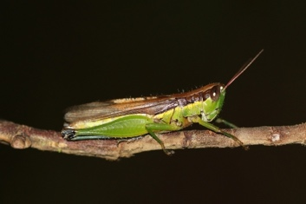
Q1: Insects are considered “harmful” because some of them carry diseases and ______.
- Damage crops
- Pollinate flowers
- Eat rotting plant material
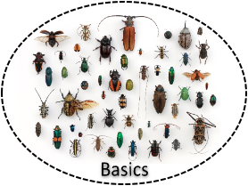

Correct: Collect Basics Token
Go to Next Screen
Incorrect: Try Again

Narrator (Professor Kafka): Hmm… maybe that was too easy. Let’s see what you know about insect body structure.

Option A: Body Structure
Go to Body Structure

Option B: Exit the Game
Exit

Body Structure
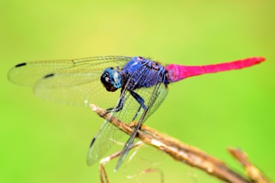
Q1: Insects do not have a backbone. They belong to a class of animals called ______.
- Vertebrates
- Invertebrates
- Chordates

Correct: Go to Next Question
Incorrect: Try Again

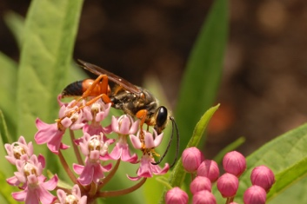
Q2: ALL insects have ______ legs.
- Six
- Eight
- Ten

Correct: Go to Next Question
Incorrect: Try Again

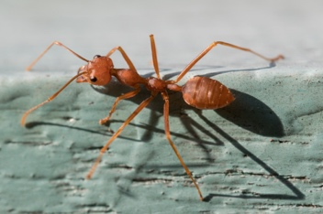
Q3: ALL insects have bodies divided into ______ parts.
- Two
- Three
- Six

Correct: Go to Next Question
Incorrect: Try Again

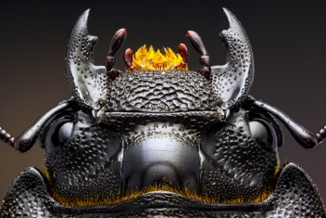
Q4: The front part of an insect’s body is called the ______.
- Beak
- Thorax
- Head

Correct: Go to Next Question
Incorrect: Try Again

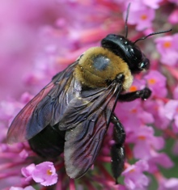
Q5: The middle part of an insect’s body is called the ______.
- Abdomen
- Thorax
- Backbone

Correct: Go to Next Question
Incorrect: Try Again

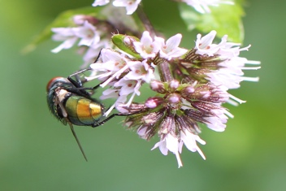
Q6: The rear part of an insect’s body is called the ______.
- Abdomen
- Thorax
- Antenna

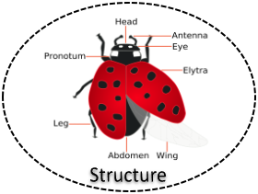
Correct: Collect Structure Token
Go to Growth & Development
Incorrect: Try Again

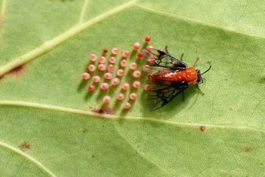
Growth & Development
Q1: ALL insects are born ______.
- From soft, gel-filled embryos
- Alive, just like mammals
- From eggs
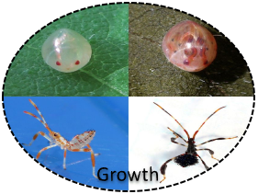

Correct: Collect Growth Token
Go to Chapter II: Wings, Water, & Wetland Wellness
Incorrect: Try Again

Chapter II: Wings, Water, & Wetland Wellness

Narrator (Professor Nguyen): Hi there! [Name], right? Welcome to Wings, Water, & Wetland Wellness! I’m Professor Ramsar Nguyen. Dr. Kafka told me you did quite well. Let’s see how familiar you are with wetland insects!

Option A: Dragonflies & Damselflies
Go to Dragonflies & Damselflies

Option B: Exit the Game
Exit

Dragonflies & Damselflies
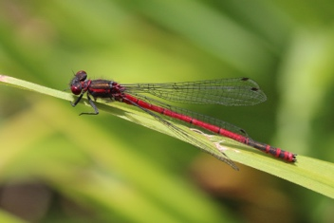
Q1: Dragonflies are most closely related to ______.
- Damselflies
- Butterflies
- House flies

Correct: Go to Next Question
Incorrect: Try Again

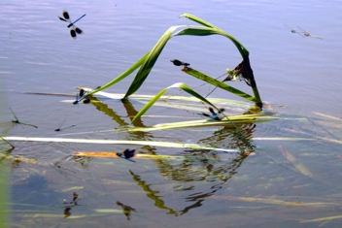
Q2: Both adult dragonflies and dragonfly nymphs live in or near ______ habitats.
- Desert
- Forest
- Aquatic

Correct: Go to Next Question
Incorrect: Try Again

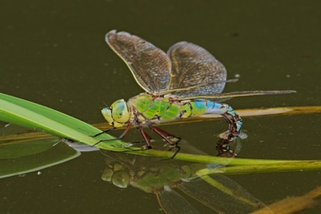
Q3: Adult dragonflies lay their eggs ______.
- In or near water
- On the ground
- In holes in logs

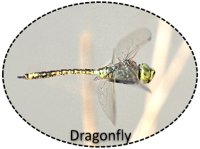
Correct: Collect Dragonfly Token
Go to Next Screen
Incorrect: Try Again

Narrator (Professor Nguyen): Wow, you pretty much aced that one. Let’s keep going.

Option A: Mayflies
Go to Mayflies

Option B: Exit the Game
Exit

Mayflies
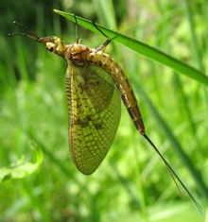
Q1: Mayflies only live approximately ______.
- 1-2 days
- 1-2 weeks
- 1-2 months

Correct: Go to Next Question
Incorrect: Try Again

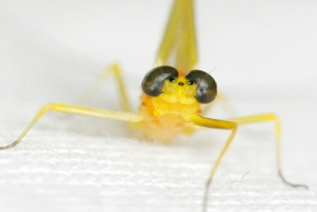
Q2: Adult mayflies do not have mouthparts and therefore do not ______.
- Sting
- Breathe
- Eat
Correct: Go to Next Question
Incorrect: Try Again

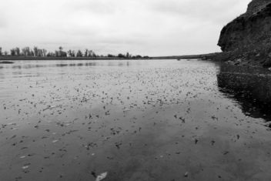
Q3: Adult mayflies and mayfly nymphs are generally found in or near ______.
- Rotting logs
- Flowing, fresh water
- Flower buds

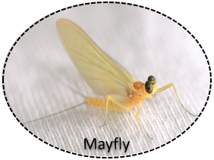
Correct: Collect Mayfly Token
Go to Next Screen
Incorrect: Try Again

Narrator (Professor Nguyen): Well, you seem to know your stuff. Let’s try some questions about a few less common aquatic insects.

Option A: Caddisflies
Go to Caddisflies

Option B: Exit the Game
Exit

Caddisflies
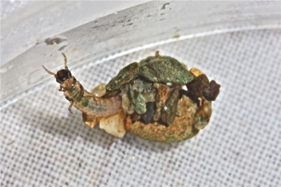
Q1: Caddisfly larvae often use silk to make ________, which they decorate with gravel, sand, and other debris.
- Protective cases
- Nests
- Webs
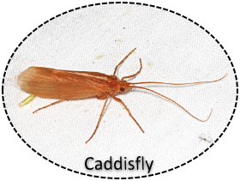

Correct: Collect Caddisfly Token
Go to Next Screen
Incorrect: Try Again

Narrator (Professor Nguyen): Well, you seem to know your stuff. Let’s try some questions about a few less common aquatic insects.

Option A: Stoneflies
Go to Stoneflies

Option B: Exit the Game
Exit

Stoneflies
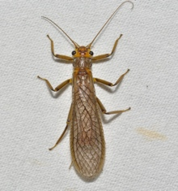
Q1: Adult stoneflies and stonefly nymphs are generally found in or near ______.
- Rotting logs
- Flowing, fresh water
- Cities

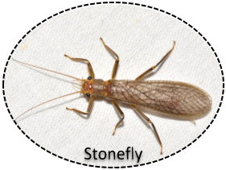
Correct: Collect Stonefly Token
Go to Chapter III: Bees, Butterflies, & Beneficial Bugs
Incorrect: Try Again

Chapter III: Bees, Butterflies, & Beneficial Bugs

Narrator (Professor Baumgardner): Hello [Name]. I’m Dr. Beatrice Baumgardner, head of the department. My colleagues have informed me that you’re making great progress. I’m not easily impressed, so I hope you’re up for a challenge.

Option A: Ants, Bees, & Wasps
Go to Ants, Bees, & Wasps

Option B: Exit the Game
Exit

Ants, Bees, & Wasps
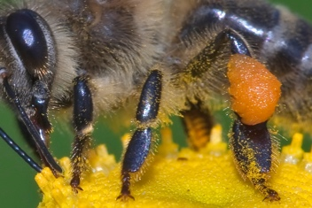
Q1: Bees, along with some wasps and ants, perform necessary and highly beneficial environmental roles as ______ of plants, crops, and flowers.
- Consumers
- Pollinators
- Controllers

Correct: Go to Next Question
Incorrect: Try Again

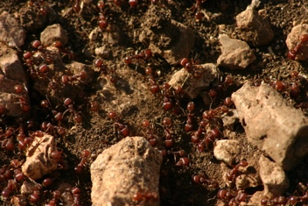
Q2: Ants, bees, and wasps live in complex communities called ______.
- Colonies
- Condominiums
- Congregations

Correct: Go to Next Question
Incorrect: Try Again

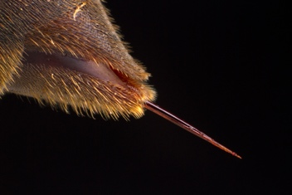
Q3: Bees and wasps have an ovipositor at the end of their abdomen that has been modified into a ______.
- Pincer
- Buzzer
- Stinger
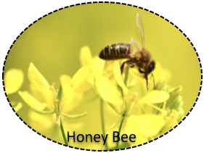

Correct: Collect Honey Bee Token
Go to Next Screen
Incorrect: Try Again

Narrator (Professor Baumgardner): Hmmm... well done. But many people know about ants, bees, and wasps. Let’s try a different group.

Option A: Butterflies & Moths
Go to Butterflies & Moths

Option B: Exit the Game
Exit

Butterflies & Moths
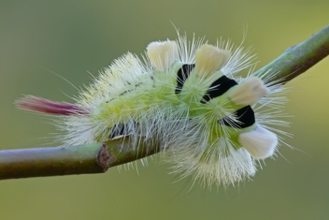
Q1: The larval form of butterflies and moths looks very different from the winged adult version. In this stage, these larvae are commonly known as ______.
- Caterpillars
- Earthworms
- Nymphs
Correct: Go to Next Question
Incorrect: Try Again

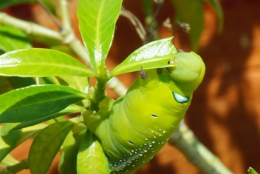
Q2: Caterpillars are known for having strong chewing mouthparts called mandibles, which they use to eat a wide variety of ______.
- Worms
- Other insects
- Plants
Correct: Go to Next Question
Incorrect: Try Again

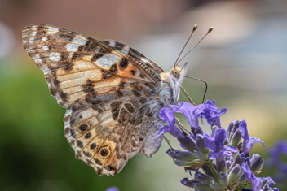
Q3: Adult butterflies and moths have a long, tube-like mouthpart called a proboscis, which they use to sip ______ from flowers.
- Pollen
- Juice
- Nectar
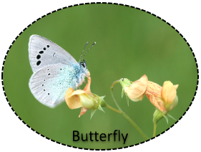

Correct: Collect Butterfly Token
Go to Next Screen
Incorrect: Try Again

Narrator (Professor Baumgardner): Butterflies are pretty popular too. Let’s try some less well-known insects.

Option A: Lacewings
Go to Butterflies & Moths

Option B: Exit the Game
Exit

Lacewings
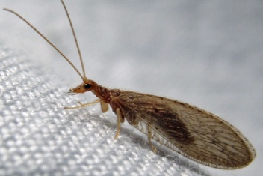
Q1: Lacewings are tremendously valued insects, mostly because they eat ______.
- Corn
- Many insect pest species
- Pollen

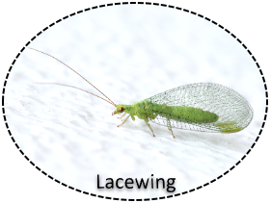
Correct: Collect Lacewing Token
Go to Next Screen
Incorrect: Try Again

Narrator (Professor Baumgardner): You’ve done pretty well. Let’s try one last group of beneficial insects.

Option A: Praying Mantises
Go to Praying Mantises

Option B: Exit the Game
Exit

Praying Mantises
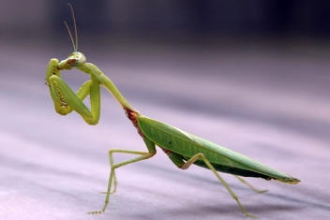
Q1: Praying mantises get their name from the way they look when hunting or at rest. They stand very still and hold their ______, which makes them look like they are praying.
- Front legs together
- Wings spread out
- Head at an angle
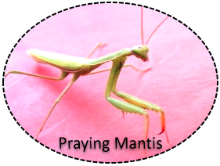

Correct: Collect Praying Mantis Token
Go to Chapter IV: Pesky & Problematic Pests
Incorrect: Try Again

Chapter IV: Pesky & Problematic Pests

Narrator (Professor Latoso): ¡Buenos dias, [Name]! My name is Dr. Lazaro Latoso and my area of expertise is in Pesky and Problematic Pests. Most people think all insects fall into this category, but really only a handful truly are. Let’s test your knowledge.

Option A: Cockroaches
Go to Cockroaches

Option B: Exit the Game
Exit Game

Cockroaches
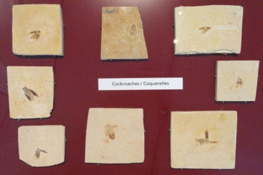
Q1: Cockroaches have been in existence for a really long time. Some scientists think they first appeared on Earth around ______ years ago.
- 200 – 350
- 2000 – 3500
- 200 – 350 million

Correct: Go to Next Question
Incorrect: Try Again

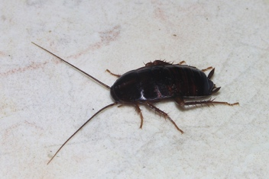
Q2: Cockroaches are super tough and resilient insects. In fact, they can survive for a long time without ______.
- Shelter
- Food and water
- Going to the bathroom

Correct: Go to Next Question
Incorrect: Try Again

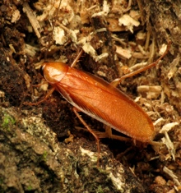
Q3: Cockroaches like tight spaces, like cracks and crevices, and they generally do not like ______.
- Damp conditions
- Warmth
- Light
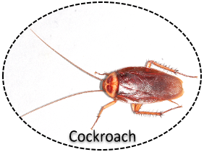

Correct: Collect Cockroach Token
Go to Next Screen
Incorrect: Try Again

Narrator (Professor Latoso): ¡Excelente, [Name]! Not a lot of people can appreciate a cockroach... not even me. Let’s see how you do with some other popular pests.

Option A: Flies & Mosquitoes
Go to Flies & Mosquitoes

Option B: Exit the Game
Exit

Flies & Mosquitoes
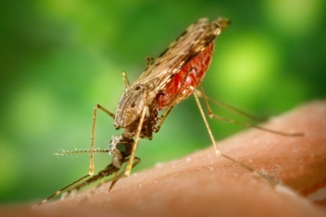
Q1: Mosquitoes have ______ mouthparts, which are especially useful for feeding on animals (including us humans) for their blood.
- Grinding
- Chewing
- Piercing-sucking
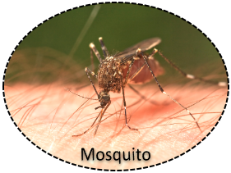

Correct: Collect Mosquito Token
Go to Next Screen
Incorrect: Try Again

Narrator (Professor Latoso): ¡Increible! You definitely know your stuff. Let’s look at some crop pests next.

Option A: Grasshoppers, Crickets, & Katydids
Go to Grasshoppers, Crickets, & Katydids

Option B: Exit the Game
Exit

Grasshoppers, Crickets, & Katydids
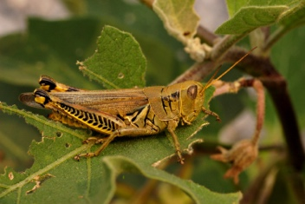
Q1: Grasshoppers are well known for their tremendous appetites. They have ______ mouthparts, and can destroy large numbers of crops and grasses very quickly.
- Chewing
- Grinding
- Sponging

Correct: Go to Next Question
Incorrect: Try Again

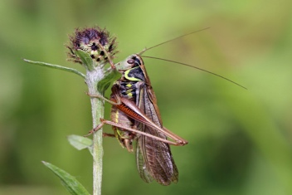
Q2: Grasshoppers, crickets, and katydids all have one characteristic in particular in common. These insects have large, strong hind legs specially adapted for ______.
- Flying
- Jumping
- Running
Correct: Go to Next Question
Incorrect: Try Again

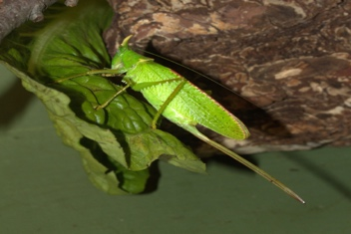
Q3: Grasshoppers, crickets, and katydids generally lay their eggs in ______.
- Water
- Trees
- The ground
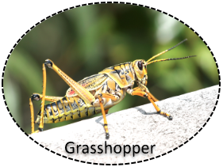

Correct: Collect Grasshopper Token
Go to Next Screen
Incorrect: Try Again

Narrator (Professor Latoso): Wow, great job! Let’s try one last chapter question.

Option A: Termites
Go to Termites

Option B: Exit the Game
Exit

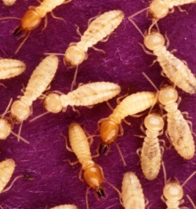
Termites
Q1: Termites are very destructive insects that do a lot of damage to homes and other buildings. Bacteria and enzymes in their gut help them to digest ______, which is their primary choice for food.
- Wood
- Nectar
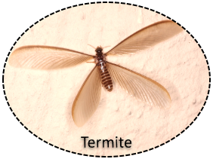
- Pollen

Correct: Collect Termite Token
Go to Chapter V: Diverse, Different, & Distinct
Incorrect: Try Again

Chapter V: Diverse, Different, & Distinct

Narrator (Professor Berkley): Greetings. I’m Dr. Bernard Berkley. I understand you have been invited to speak at our upcoming summit. This event is hugely important, so don’t expect me to go easy on you.

Option A: Beetles
Go to Beetles

Option B: Exit the Game
Exit

Beetles
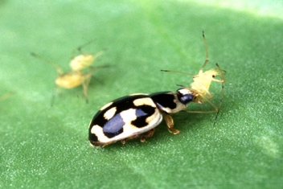
Q1: Many beetles, like ladybird beetles (aka ladybugs) are considered beneficial insects, mostly because they are predatory and attack many different kinds of ______.
- Agricultural crops
- Insect pests
- Birds

Correct: Go to Next Question
Incorrect: Try Again

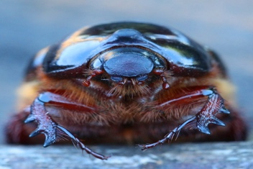
Q2: Many types of beetles, like some scarab beetles, are considered pests, mostly because they attack many different kinds of ______ and contaminate stored grain products.
- Agricultural crops
- Beneficial insect species
- Birds

Correct: Go to Next Question
Incorrect: Try Again
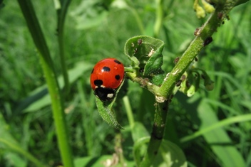
Q3: Ladybugs are one of the most easily recognizable, common beetles. These insects usually have round to oval shaped bodies and are often very brightly colored with black ______.
- Antennae
- Wings
- Spots
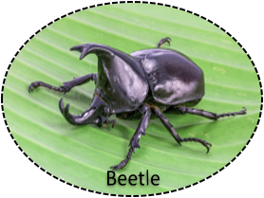

Correct: Collect Beetle Token
Go to Next Screen
Incorrect: Try Again

Narrator (Professor Berkley): Well, those certainly weren’t easy questions, but I have to admit you did pretty well. I’m going to have to up my game this next round.

Option A: True Bugs
Go to True Bugs

Option B: Exit the Game
Exit

True Bugs
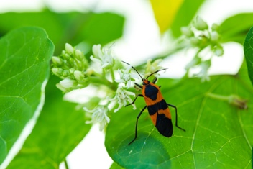
Q1: There are many different kinds of insects that are considered true bugs (hemipterans). Some, like bed bugs, are parasitic and feed on the blood of animals (including us humans); some, like assassin bugs, are predators, often attacking other insects. Most bugs, however, feed on ______.
- Mushrooms
- Plants
- Manure

Correct: Go to Next Question
Incorrect: Try Again

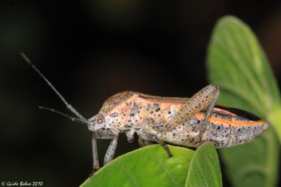
Q2: Most bugs have very specialized mouthparts that enable them to feed on a variety of plants, animals, or other insects. Mouthparts associated with the true bugs are generally classified as ______ mouthparts.
- Chewing
- Piercing-sucking
- Sponging

Correct: Go to Next Question
Incorrect: Try Again
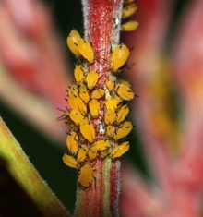
Q3: Many types of bugs, including aphids and scale insects, are significant pests of ______.
- Agricultural crops, flowers, and garden plants
- Beneficial insect species
- Fungi
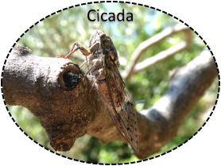

Correct: Collect Cicada Token
Go to Next Screen
Incorrect: Try Again

Narrator (Professor Berkley): Incredibly, I haven’t been able to stump you yet. Let’s see what you do with this next set of questions.

Option A: Earwigs
Go to Earwigs

Option B: Exit the Game
Exit

Earwigs
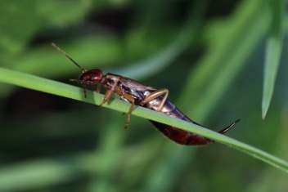
Q1: Earwigs are one of the most easily recognizable insects. One of their key identifying body characteristics is ______.
- A pair of forceps-like pinchers on the end of the abdomen
- A pair of overly large antennae on the front of the head
- A pair of large, triangular wings attached to the thorax
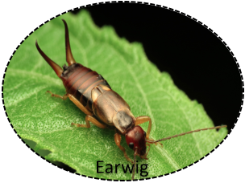

Correct: Collect Earwig Token
Go to Next Screen
Incorrect: Try Again

Narrator (Professor Berkley): Okay... I’m pulling out the last stops. Let’s try one last chapter to see just how smart you really are.

Option A: Walking Sticks
Go to Walking Sticks

Option B: Exit the Game
Exit

Walking Sticks
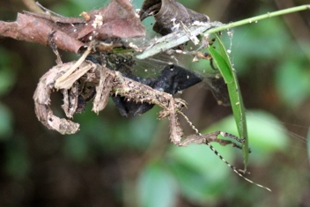
Q1: Walking sticks, like their name suggests, are long, slender insects that closely resemble twigs. They use their ______ to hide from predators.
- Body shape and coloration
- Large size
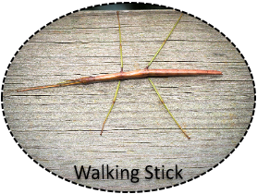
- Small size

Correct: Collect Walking Stick Token
Go to Chapter VI: Endangered Endemic Entomology
Incorrect: Try Again

Chapter VI: Endangered Endemic Entomology

Narrator (Professor Doodlebug): Welcome back, [Name]. I see you’ve made it through all of our professors’ challenges. Well done! I have a couple final questions for you regarding our state’s endangered insects.

Option A: Go to Next Screen

Nebraska’s Endangered Insects
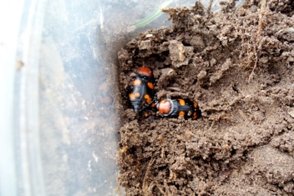
Q1: The American Burying Beetle gets its name from an interesting behavior that it has. These beetles will actually bury the bodies of ______ and use them as a place for laying their eggs.

- Small animals
- Other insects
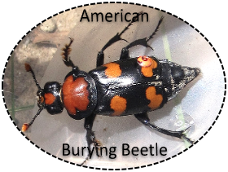
- Snails

Correct: Collect American Burying Beetle Token
Go to Next Question
Incorrect: Try Again

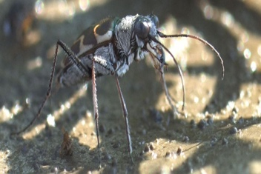
Q2: The Salt Creek Tiger Beetle is a highly active, ground-dwelling insect that is native to a very specific type of wetland habitat in eastern Nebraska. These beetles are voracious ______ that feed on other insects.
- Predators
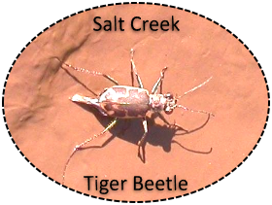
- Herbivores
- Pollinators

Correct: Collect Salt Creek Tiger Beetle Token
Go to Next Screen
Incorrect: Try Again

Narrator (Professor Doodlebug): Way to go, [Name]!! That was the last question! Let's verify that you've collected all the tokens!

Option A: Great! Here are all my tokens!
Go to Next Screen

Winner Splash Page: CONGRATULATIONS!!! You collected all required items! Fantastic job!

Option A: Thanks so much! See you guys at the summit!!
Go to Next Screen

Conclusion: Thanks for playing! We hope you enjoyed the game! Check back soon for more episodes!

Option A: Good-bye!
Exit the Game

References

Barbezat, S. (2019). Monarch Butterfly Reserves in Mexico. TripSavvy [Website]. https://www.tripsavvy.com/mexicos-monarch-butterfly-reserves-1588943

Beneficial Bugs of North America. (2019). The Dragonfly Family. http://beneficialbugs.org/bugs/ Dragonfly/dragonfly.htm

Billinghurst, M., Clark, A. & Lee, G. (2014). A Survey of Augmented Reality. Foundations and Trends® in Human-Computer Interaction, 8(2-3): 73-272. https://is.muni.cz/el/1433/podzim2015/PA198/ um/59482554/A_Survey_of_Augmented_Reality.pdf

Billinghurst, M., & Duenser, A. (2012). Augmented Reality in the Classroom. Computer. 45:56-63. https://www.researchgate.net/publication/234793015_Augmented_Reality_ in_the_Classroom

Borror, D. (1970). Peterson Field Guides--Insects. New York: Houghton-Mifflin Co.

Eaton, E. R., Kaufman, K., Bowers, R., & Bowers, N. (2007). Kaufman Field Guide to Insects of North America. New York: Houghton Mifflin Co.

Goodreads. (2019). Benjamin Franklin Quotes. https://www.goodreads.com/quotes/21262-tell-me-and-i-forget-teach-me-and-i-may

Murawski, D., & Honovich, N. (2013). Ultimate Bugopedia: The Most Complete Bug Reference Ever. Washington, D.C.: National Geographic Kids

Murray, J. (2018, November 26). Metaverse—Education Game-changer. Ask a Tech Teacher [Blog]. https://askatechteacher.com/metaverse-a-different-reality/

Ramel, G. (2019). Dragon-flies (Odonata). Earthlife [Website]. https://www.earthlife.net/insects/ odonata.html

Triplehorn, C., & Johnson, N. (2005). Borror and DeLong's Introduction to the Study of Insects (7th ed.). Belmont, CA: Brooks/Cole

U.S. Fish & Wildlife Service. (2019). American Burying Beetle. U.S. Department of the Interior. https://www.fws.gov/mountain-prairie/es/americanBuryingBeetle.php

U.S. Fish & Wildlife Service. (2019). Salt Creek Tiger Beetle. U.S. Department of the Interior. https://www.fws.gov/mountain-prairie/es/saltCreekTigerBeetle.php

Weissling, T. M. (2019). ENTO818 Insect ID and Natural History [Lecture notes]. University of Nebraska – Lincoln, Department of Entomology. https://canvas.unl.edu/courses/54920

References – Digital Photos

Bauer, S. (USDA ARS). [photo]. (2005). Coptotermes formosanus shiraki USGov k8204-7.
https://commons.wikimedia.org/wiki/File:Coptotermes_formosanus_shiraki_USGov_k8204-7.jpg

Bauer, S. (USDA ARS). [photo]. (2005). P-14 lady beetle. https://commons.wikimedia.org/wiki/File:P-14_lady_beetle.jpg

Baužys, D. [photo]. (2009). Calliteara pudibunda caterpillar. https://commons.wikimedia.org/wiki/ File:Calliteara_pudibunda_caterpillar.jpg

Bohne, G. [photo]. (2010). Sweetpotato bug (Coreidae), a herbivore ... (5101467259).
https://commons.wikimedia.org/wiki/File:Sweetpotato_bug_(Coreidae),_a_herbivore_..._(5101467259).jpg

Cannizzaro, A. [photo]. (2015). Northern Walkingstick (Diapheromera femorata) (21144673140).
https://commons.wikimedia.org/wiki/File:Northern_Walkingstick_(Diapheromera_femorata)_(21144673140).jpg

Cebeci, Z. [photo]. (2015). Butterfly Green-underside Blue - Glaucopsyche alexis 01.
https://commons.wikimedia.org/wiki/File:Butterfly_Green-underside_Blue_-_Glaucopsyche_alexis_01.jpg

Daderot. [photo]. (2011) Fossil cockroaches – Royal Ontario Museum – DSC00011.
https://commons.wikimedia.org/wiki/File:Fossil_cockroaches_-_Royal_Ontario_Museum_-_DSC00011.JPG

Eichler, A. [photo]. (2017). 2017.06.05.-09-Anglerteiche-Rimbach--Grosse Koenigslibelle-Weibchen bei Eiablage. https://commons.wikimedia.org/wiki/File:2017.06.05.-09-Anglerteiche-Rimbach--Grosse_Koenigslibelle-Weibchen_bei_Eiablage.jpg

Gallagher, J. [photo]. (2013). Caddisfly, SFSU Field Campus, Bassetts, California.
https://commons.wikimedia.org/wiki/File:Caddisfly,_SFSU_Field_Campus,_Bassetts,_California.jpg

Gaspar, J. [photo]. (2007). Cockroach May 2007-1. https://commons.wikimedia.org/wiki/File:Cockroach_ May_2007-1.jpg

Gaspar, J. [photo]. (2008). Aphids September 2008-1. https://commons.wikimedia.org/wiki/File:Aphids_ September_2008-1.jpg

Gaspar, J. [photo]. (2013). Crisopid July 2013-9. https://commons.wikimedia.org/wiki/File:Crisopid_ July_2013-9.jpg

Gathany, J. [photo]. (2005) Anopheles albimanus mosquito. https://commons.wikimedia.org/wiki/ File:Anopheles_albimanus_mosquito.jpg

Harrison, J. [photo]. (2009). Mosquito Tasmania. https://commons.wikimedia.org/wiki/File:Mosquito_ Tasmania.jpg

Heinonlein. [photo]. (2015). Walking stick in Isalo. https://commons.wikimedia.org/wiki/File:Walking_ stick_in_Isalo.JPG

Henricks, B. [photo]. (2012). Saddle-case case-maker caddisfly larva (7234729126) https://commons.wikimedia.org/wiki/File:Saddle-case_case-maker_caddisfly_larva_ (7234729126).jpg

Hillewaert, H. [photo]. (2009). Sericoceros mexicanus (female laying eggs). https://commons.wikimedia.org/wiki/File:Sericoceros_mexicanus_(female_laying_eggs).jpg

Hume, G. [photo]. (2017). Copiphora rhinoceros – female. https://commons.wikimedia.org/wiki/ File:Copiphora_rhinoceros_-_female.jpg

Insects Unlocked. [photo]. (2015). Assorted Coleoptera in the University of Texas Insect Collection. https://commons.wikimedia.org/wiki/File:Assorted_Coleoptera_in_the_University_of_Texas_Insect_Collection.jpg

Isiwal. [photo]. (2019). Vanessa cardui on Lavandula angustifolia-2459. https://commons.wikimedia.org/ wiki/File:Vanessa_cardui_on_Lavandula_angustifolia-2459.jpg

Jones, J. (USFWS Mountain-Prairie) [photo]. (2012). American Burying Beetles (7463093576). https://commons.wikimedia.org/wiki/File:American_Burying_Beetles_(7463093576).jpg

Kaaby, F. [photo]. (2014). Mayfly 3. https://commons.wikimedia.org/wiki/File:Mayfly_3.JPG

Kaaby, F. [photo]. (2014). Mayfly 4. https://commons.wikimedia.org/wiki/File:Mayfly_4.jpg

Keats, D. [photo]. (2010). Flying Termite. https://commons.wikimedia.org/wiki/File:Flying_Termite.jpg

Kimmel, B. [photo]. (2010). American cockroach mirror. Derived from original photo by Gary Alpert. https://commons.wikimedia.org/wiki/File:American-cockroach_mirror.png

Koerner, T. (USFWS Mountain-Prairie) [photo]. (2016). Mayfly Hatch on Seedskadee National Wildlife Refuge (26716824000). https://commons.wikimedia.org/wiki/File:Mayfly_Hatch_on_ Seedskadee_National_Wildlife_Refuge_(26716824000).jpg

Lamiot, F. [photo]. (2011). PollenApis mellifera Western honey beeDetail. Derived from original photo by Andreas Trepte. https://commons.wikimedia.org/wiki/File:PollenApis_mellifera_Western_ honey_beeDetail.jpg

Law, K. [photo]. (2008). Flickr - law keven - Dameselfy Central. https://commons.wikimedia.org/wiki/ File:Flickr_-_law_keven_-_Dameselfy_Central....jpg

Loser, I. [photo]. (2012). Acanthocephala terminalis (stages of development). https://commons.wikimedia.org/wiki/File:Acanthocephala_terminalis_(stages_of_development).jpg
Lucier, J. [photo]. (2011). Brown Lacewing Micromus subanticus. https://commons.wikimedia.org/wiki/ File:Brown_Lacewing_Micromus_subanticus.jpg

McMasters, M. [photo]. (2016). Large milkweed bug (29038261571). https://commons.wikimedia.org/ wiki/File:Large_milkweed_bug_(29038261571).jpg

Miles, B. (USFWS Mountain-Prairie). [photo]. (n.d.). Salt Creek Tiger Beetle. https://www.fws.gov/ mountain-prairie/es/saltCreekTigerBeetle.php
Morin, B. [photo]. (2010). Xylotrupes socrates (Siamese rhinoceros beetle). https://commons.wikimedia.org/wiki/File:Xylotrupes_socrates_(Siamese_rhinoceros_beetle).jpg

Morin, B. [photo]. (2018). Close-up photograph of Oecophylla smaragdina (Red weaver ant). https://commons.wikimedia.org/wiki/File:Close-up_photograph_of_Oecophylla_smaragdina_ (Red_weaver_ant).jpg

Orlando, G. [photo]. (2007). Ladybug aphids. https://commons.wikimedia.org/wiki/File:Ladybug_ aphids.JPG

Persian Poet Gal [photo]. (2007). Coccinellidae (Ladybug) Anatomy. https://commons.wikimedia.org/ wiki/File:Coccinellidae_(Ladybug)_Anatomy.svg

Pons, J. [photo]. (2017). Sand scarab beetle pericoptus truncata. https://commons.wikimedia.org/wiki/ File:Sand_scarab_beetle_pericoptus_truncata.jpg

Poon, W. [photo]. (2005). A Texas Ant Colony. https://commons.wikimedia.org/wiki/File:A_Texas_Ant_ Colony.jpg

Ramsey, D. [photo]. (2007). Swamp Milkweed Asclepias incarnata Insect Feeding 3008px. https://commons.wikimedia.org/wiki/File:Swamp_Milkweed_Asclepias_incarnata_Insect_Feeding_3008px.jpg

Ramsey, D. [photo]. (2008). Grasshopper Eating Eggplant Leaf 3008px. https://commons.wikimedia.org/ wiki/File:Grasshopper_Eating_Eggplant_Leaf_3008px.jpg

Reago, A. & McClarren, C. [photo]. (2019). Stonefly (47995019598). https://commons.wikimedia.org/ wiki/File:Stonefly_(47995019598).jpg

Reago, A. & McClarren, C. [photo]. (2019). Stonefly (47995055116). https://commons.wikimedia.org/ wiki/File:Stonefly_(47995055116).jpg

San Martin, G. [photo]. (2017). Honey bee on White mustard (48325636566). https://commons.wikimedia.org/wiki/File:Honey_bee_on_White_mustard_(48325636566).jpg

Sayannalanda. [photo]. (2016). The invertebrate. https://commons.wikimedia.org/wiki/File:The_ invertebrate.jpg

Schulz, K. [photo]. (2016). European Earwig - Flickr - treegrow. https://commons.wikimedia.org/wiki/ File:European_Earwig_-_Flickr_-_treegrow.jpg
Schulz, K. [photo]. (2017). Wood Cockroach (34157161934). https://commons.wikimedia.org/wiki/ File:Wood_Cockroach_(34157161934).jpg

Sebastián, J. [photo]. (2017). Dorcus parallelipipedus female. https://commons.wikimedia.org/wiki/ File:Dorcus_parallelipipedus_female.jpg

Shankar, S. [photo]. (2005). Praying mantis india. https://commons.wikimedia.org/wiki/File:Praying_ mantis_india.jpg

Sharp, C. [photo]. (2014). Peacock Butterfly (Aglais io). https://commons.wikimedia.org/wiki/ File:Peacock_butterfly_(Aglais_io)_2.jpg

Sharp, C. [photo]. (2015). Chinese rice grasshopper (Oxya chinensis). https://commons.wikimedia.org/ wiki/File:Chinese_rice_grasshopper_(Oxya_chinensis).jpg

Sharp, C. [photo]. (2015). Large red damselfly (Pyrrhosoma nymphula) male Dry Sandford. https://commons.wikimedia.org/wiki/File:Large_red_damselfly_(Pyrrhosoma_nymphula)_male_Dry_Sandford.jpg

Sharp, C. [photo]. (2015). Roesel Bush-cricket (Metrioptera roeselii diluta) male. https://commons.wikimedia.org/wiki/File:Roesel%27s_bush-cricket_(Metrioptera_roeselii_ diluta)_male.jpg

Sharp, C. [photo]. (2016). Earwig (Forficular auricularia) female. https://commons.wikimedia.org/wiki/ File:Earwig_(Forficula_auricularia)_female.jpg

Sksiddhartthan. [photo]. (2017). Oleander hawk moth caterpillar on a plant. https://commons.wikimedia.org/wiki/File:Oleander_hawk_moth_caterpillar_on_a_plant.jpg

Syrio. [photo]. (2019). Cicada orni Allodole 05. https://commons.wikimedia.org/wiki/File:Cicada_orni_ Allodole_05.jpg

Vicol, E. [photo]. (2010). Praying mantis Locusta (4791515969). https://commons.wikimedia.org/wiki/ File:Praying_mantis_Locusta_(4791515969).jpg

Vivian, L. (USFWS Mountain-Prairie) [photo]. (2012). American Burying Beetle. https://commons.wikimedia.org/wiki/File:American_Burying_Beetle.jpg

Vivian, L. (USFWS Mountain-Prairie) [photo]. (2012). American Burying Beetle (7489198288). https://commons.wikimedia.org/wiki/File:American_Burying_Beetle_(7489198288).jpg

Wild, A. [photo]. (2015). Stinger of Polistes Carolina. https://commons.wikimedia.org/wiki/File:Stinger_ of_Polistes_Carolina.jpg

Wiley, S. (USFWS Mountain-Prairie) [photo]. (2003). Salt Creek Tiger Beetle. https://commons.wikimedia.org/wiki/File:Salt_Creek_Tiger_Beetle.jpg

Wilkins, J. [photo]. (2013). Blow Fly abdomen. https://commons.wikimedia.org/wiki/File:Blow_Fly_ abdomen.jpg
Wilkins, J. [photo]. (2013). Carpenter Bee thorax and wings. https://commons.wikimedia.org/wiki/ File:Carpenter_Bee_thorax_and_wings.jpg

Winterflood, G. [photo]. (2018). Australian Emperor. https://commons.wikimedia.org/wiki/ File:Australian_Emperor_6630.jpg

Wood, R. [photo]. (2007). Grasshopper 2. https://commons.wikimedia.org/wiki/File:Grasshopper_2.JPG

Zapyon. [photo]. (2011). Große Eintagsfliege, mayfly, Ephemera danica 2011-05-03 IMG 1125 EDIT2 SQUARE CUT 1600x1600. https://commons.wikimedia.org/wiki/File:Gro%C3%9Fe_ Eintagsfliege,_mayfly,_Ephemera_danica_2011-05-03_IMG_1125_EDIT2_SQUARE_CUT_ 1600x1600.jpg

Appendix A – Optional Intermediate Level Game Question Bank

Chapter I: Intro to Important Insect Info

Basics
Q1: Insects are considered “helpful” because they pollinate many flowers and plants, and they ______.
- Spread diseases
- Keep crops under control
- Act as key parts of many food webs

Body Structure
Q1: Some insects have ______, which are attached to their thorax and used for flying.
- Legs
- Wings
- Feathers

Q2: Insects have two ______, which are attached to their head and used for sensing things in their surrounding environment.
- Stingers
- Mouthparts
- Antennae

Q3: In most insects, their ______ are attached to their thorax and help them move.
- Mouthparts
- Legs
- Antennae

Q4: The specialized structures insects use for feeding are called ______.
- Mouthparts
- Siphons
- Antennae

Q5: An insect’s internal organs for digesting its food are located in the insect’s ______.
- Head
- Thorax
- Abdomen

Q6: An insect’s internal organs for laying eggs and reproduction are located in the insect’s ______.
- Head
- Thorax
- Abdomen

Growth and Development
Q1: The growth change process that an insect goes through as it develops from an egg to an adult is called ______.
- Hatching
- Metamorphosis
- Pupation

Chapter II: Wings, Water, & Wetland Wellness

Dragonflies & Damselflies
Q1: When dragonfly eggs hatch, a ______ emerges.
- Nymph
- Pupa
- Adult

Q2: Dragonflies have incredibly large eyes – they cover most of their heads and each eye has up to 28,000 lenses. These types of eyes are called ______ eyes.
- Compound
- Simple
- Magnifying

Q3: Dragonflies can see very well and spot prey easily. They often catch small, flying insects with their legs and ______.
- Carry them back to their nest
- Eat them in mid-air
- Wrap them in silk

Q4: Dragonflies are considered helpful insects because they eat _________.
- Pests like mosquitoes, midges, and gnats
- Stinging insects like bees and wasps
- Pests like cockroaches, flies, and termites

Mayflies
Q1: Mayflies have ______ wings, which are held vertically above their body when the insect is at rest.
- Rectangular
- Triangle-shaped
- Square

Q2: Many animals feed on the mass swarms of mayflies that often emerge each year, making mayflies a very important part of the ______.
- Nitrogen cycle
- Food chain
- Water cycle

Q3: Different species of mayflies can be identified, in part, by the number of ______ present.
- Tail filaments
- Leg segments
- Antennae

Q4: Mayfly hatches can be so large, with so many insects emerging at once, that they can be seen ______.
- On weather radar
- From outer space
- By the International Space Station

Caddisflies
Q1: Caddisfly larvae live in ______ environments, mostly in ______ habitats.
- Forested; dark, damp
- Aquatic; cool, fresh water
- Dry; warm desert

Stoneflies
Q1: To find a mate, a male stonefly will produce noise by tapping or rubbing his body against rocks, logs, or branches. This is called ______ and the vibrations help attract females.
- Drumming
- Humming
- Chirping

Chapter III: Bees, Butterflies, & Beneficial Bugs

Ants, Bees, & Wasps
Q1: Ants live in colonies led by a single female ______, whose job it is to lay eggs.
- Princess
- Queen
- Worker

Q2: Ants, bees, and wasps develop through ______ distinct growth stages. After hatching from eggs, they transition from larvae to pupae to finally adults. This type of development is called complete metamorphosis.
- Four
- One
- Three

Q3: Bees and wasps are similar in color, but can be told apart by a few differences in body features. Honeybees are fuzzier and have short, rounded bodies, whereas wasps are not fuzzy or hairy, and have ______ bodies.
- Long, fat
- Long, skinny
- Short, skinny

Butterflies & Moths
Q1: One way to tell butterflies and moths apart is by the way they hold their wings. In general, butterflies hold their wings ______ while at rest.
- Horizontal away from their bodies
- Vertical over their bodies
- Roof-like or flattened over their bodies

Q2: One way to tell butterflies and moths apart is by the way they hold their wings. In general, moths hold their wings ______ while at rest.
- Horizontal away from their bodies
- Vertical over their bodies
- Roof-like or flattened over their bodies

Q3: Another way to tell butterflies and moths apart is by the time of day in which they are most active. In general, butterflies are diurnal, meaning they are active during the ______.
- Day
- Night
- Winter

Q4: Another way to tell butterflies and moths apart is by the time of day in which they are most active. In general, moths are nocturnal, meaning they are active during the ______.
- Day
- Night
- Winter

Lacewings
Q1: Lacewings are often sold by organic gardeners as biological weapons against insect pests. Lacewing larvae are especially useful because they are very fond of eating ______.
- Ants
- Other lacewings
- Aphids

Praying Mantises
Q1: Praying mantises have ______ on their front legs, which allows them to hold struggling prey.
- Spikes
- Glue
- Pincers

Chapter IV: Pesky & Problematic Pests

Cockroaches
Q1: In addition to being associated with dirty or unclean conditions, cockroaches can also carry many different types of ______.
- Diseases
- Parasites
- Intestinal worms
Q2: Cockroaches lay their eggs in a special type of case called a/an ______.
- Capsule
- Pod
- Ootheca

Q3: There are many different types of cockroaches. The one most associated with dirty or unclean conditions is the German cockroach. These insects can be identified, in part, by the two ______ on their thorax.
- Large spots
- Vertical stripes
- Small spines

Q4: Cockroaches emit a number of special chemicals called ______, which form a scent trail that helps other cockroaches find food and water sources.
- Pheromones
- Fragrances
- Perfumes

Flies & Mosquitoes
Q1: Flies and mosquitos belong to the insect order Diptera. These insects, especially the mosquitoes, are considered pests, mostly because they ______.
- Damage millions of dollars of crops every year
- Carry and transmit a large number of diseases
- Contaminate stored food and dried grains

Grasshoppers, Crickets, & Katydids
Q1: Grasshoppers, crickets, and katydids lay their eggs using a special structure at the end of their abdomen called an ______.
- O-ring
- Ovary
- Ovipositor

Q2: Young grasshoppers, crickets, and katydids usually look just like smaller versions of their parents. After hatching from an egg, and until they reach adulthood, they are referred to as ______.
- Pupa
- Nymphs
- Larvae

Q3: Crickets are known for the noises they make (their “songs”). Their characteristic chirps help them to find mates and ______.
- Signal danger
- Tell the time of day
- Find food

Termites
Q1: Termites live in large social colonies controlled by a single female. This female is called the ______.
- Queen
- Princess
- Duchess

Chapter V: Diverse, Different, & Distinct

Beetles
Q1: Lightning bugs (or fireflies) are actually a species of beetle. They have special organs at the end of their lower abdomen that produce light that they use as a signal to other lightning bugs. On summer evenings, lightning bugs can be seen emitting flashes of light to attract ______.
- Prey
- Mates
- Birds

Q2: Beetles develop through four distinct growth stages. After hatching from eggs, they transition from larvae to pupae to finally adults. This four-stage type of development is called ______ metamorphosis.
- Complete
- Final
- Growth

Q3: Dung beetles are famous for their fascination with manure (poop). Although this might seem strange, dung beetles are actually very beneficial insects. Not only do they clean up a lot of nasty waste, but when they bury it in the ground, they are actually helping ______.
- Fertilize the soil
- Cover up bad smells
- Hide from predators

Q4: Some long-horned beetles have ______ that sweep backward and are nearly always at least half as long as their overall body length, if not longer.
- Antennae
- Wings
- Legs

True Bugs
Q1: It is sometimes very difficult to distinguish true bugs from beetles. The two different insect types do look a lot alike. However, true bugs can be identified based on their ______.
- Elytra
- Wing size
- Type of mouthparts

Q2: The piercing-sucking mouthparts of true bugs are referred to by a few different scientific names. These include proboscis, rostrum, and ______.
- Elytra
- Beak
- Sucker

Q3: Stink bugs are fairly common and can be either brown or green in color, with a shield- or triangular-shaped body. As their name indicates, they can emit a smelly odor when threatened. This helps protect them from being eaten by ______.
- Humans
- Other insects
- Predators like birds

Q4: Cicadas are the largest of all bug species, and can grow to be up to 2 inches in length. Male cicadas have special, sound-producing organs in their abdomens that allows them to “sing” to attract females. Their “songs” can be described as loud, buzzing sounds, and are most often heard in ______.
- Summer
- Winter
- Fall

Earwigs
Q1: Earwigs are mostly scavengers or herbivorous, feeding on ______.
- Pollen
- Nectar
- A variety of plant and animal matter

Walking Sticks
Q1: Walking sticks, like their name suggests, are long, slender insects that closely resemble twigs. They are one of the many examples of insects that use ______ to avoid predators.
- Poisonous stingers
- Size differences
- Camouflage

Chapter VI: Endangered Endemic Entomology

Nebraska’s Endangered Species
Q1: American Burying Beetles can be identified by a bright orange patch in the area between the head and the body. This portion of the ______ is called the pronotum.
- Antennae
- Thorax
- Abdomen

Q2: Salt Creek Tiger Beetles only live in the ______ wetlands of Lancaster County, near Lincoln, Nebraska.
- Eastern freshwater
- Western saline (salt)
- Eastern saline (salt)

Appendix B – Optional Advanced Level Game Question Bank

Chapter I: Intro to Important Insect Info

Basics
Q1: The number of insect species worldwide is approximately ….. One of the reasons why insects are so successful is because they have ______.
- Become specialized and have strict diets
- Adapted to just about every environment and have varied diets
- All learned how to fly and catch prey in mid-air

Body Structure
Q1: An insect’s body has a hard, protective outer covering called an ______.
- Exoskeleton
- Epidermis
- Endodermis

Q2: An insect’s exoskeleton is made up of a hard, protective material called ______.
- Calcium
- Chitin
- Chromium

Q3: Butterflies and moths have a long, tube-like mouthpart that they use to suck up nectar like a straw. This specialized mouthpart is called a/an ______.
- Proboscis
- Prober
- Sucker-upper

Q4: Insects often give off or put out a mixture of chemical scents that helps them find food or mates. These chemicals are called ______.
- Pesticides
- Pheromones
- Phthalates

Q5: Insects do not have the same type of lungs and organs for respiration that we have. In fact, they breathe through small air holes in their body wall. These air holes are called ______.
- Portholes
- Spaces
- Spiracles

Q6: Even though they are arthropods, spiders are not considered insects because they have bodies divided into ______ parts and ______ legs.
- Two, eight
- Three, eight
- Two, six

Growth and Development
Q1: Insects must shed their hard exoskeleton in order to grow. This process is called ______.
- Hatching
- Pupation
- Molting

Wings, Water, & Wetland Wellness

Dragonflies & Damselflies
Q1: A good way to tell dragonflies and damselflies apart is by the way they hold their wings. Dragonflies rest with their wings ______, while damselflies rest with their wings ______.
- Held straight out, away from their body; held together above their body
- Held straight out, away from their body; at 45-degree angles above their body
- Held above their body; held straight out, away from their body

Q2: Dragonfly nymphs breathe underwater through the use of ______.
- Captured air bubbles
- Internal gills
- Siphon tubes

Q3: Dragonfly nymphs are ______ and feed on ______.
- Herbivorous; underwater plants
- Omnivorous; plankton and algae
- Carnivorous; mostly other invertebrates

Mayflies
Q1: Mayflies are considered environmental quality indicator species because they are only found in areas with ______ water.
- Polluted
- Unpolluted
- Extremely muddy

Q2: Mayfly distribution patterns can be used to help monitor environmental changes and can help identify areas of increased or decreased ______.
- Rainfall
- Temperature
- Pollution

Q3: Mayflies have a unique, intermediate development stage that occurs during the transition between nymph and adult. This stage is called a ______.
- Pupa
- Subimago
- Chrysalis

Caddisflies
Q1: Much like mayflies, caddisflies are considered water quality indicators because they are very sensitive to ______.
- Dissolved minerals
- Pollution
- Temperature

Stoneflies
Q1: Stoneflies are considered water quality indicators because they are only found in clean, cold water having high levels of ______.
- Pollution
- Dissolved minerals
- Dissolved oxygen

Chapter III: Bees, Butterflies, & Beneficial Bugs

Ants, Bees, & Wasps
Q1: Ants, bees, and wasps belong to the insect order Hymenoptera. Much like termites, they are classified as ______ insects because they live in complex communities with very specific divisions of labor or roles (e.g., workers, queens, etc.).
- Social
- Anti-social
- Mutual

Q2: Honeybees and bumblebees have a special structure on each of their hind legs that is designed to help them gather and hold grains of pollen. This structure is called a pollen ______.
- Carrier
- Bin
- Basket

Q3: Both bees and wasps are capable of delivering a very painful sting. A key difference between the two insects, however, is that a bee is only capable of stinging ______, but a wasp is capable of stinging ______.
- One time, three times
- One time, multiple times
- Two times, one time

Butterflies & Moths
Q1: Yet another way to tell butterflies and moths apart is by the way they transform from a larval caterpillar into an adult. In general, butterflies go through a pupa stage in which they develop inside a hardened ______.
- Cocoon
- Chrysalis
- Shell

Q2: Yet another way to tell butterflies and moths apart is by the way they transform from a larval caterpillar into an adult. In general, moths go through a pupa stage in which they develop inside a silk ______.
- Cocoon
- Chrysalis
- Shell

Q3: Most adult butterflies and moths do not migrate. One famous species that does, however, is the Monarch butterfly. Every year, hundreds of millions of Monarchs travel almost 3,000 miles south from Canada to their wintering grounds in ______.
- Florida
- Texas
- Mexico

Lacewings
Q1: Lacewings develop through four distinct growth stages. After hatching from eggs, they transition from larvae or nymphs to pupae to finally adults. This four-stage type of development is called ______ metamorphosis.
- Complete
- Four-stage
- Terminal

Praying Mantises
Q1: Praying mantises are ambush predators. They are often mistaken for twigs, leaves, or flowers. In this way, their coloration allows them to ______.
- Stand out from other predators
- Find mates easily
- Blend in with their environment

Chapter IV: Pesky & Problematic Pests

Cockroaches
Q1: Most people are afraid of or hate cockroaches. However, cockroaches do have a good side. For example, they are ______.
- Important pollinators of flowers and crops
- An important food source for many organisms
- Important predators of pest insects

Q2: Cockroaches are also quite good for the economy. It is estimated that, in the United States alone, nearly ______ is spent annually on professional extermination services for controlling cockroaches.
- $100,000
- $1 million
- $1 billion

Q3: Cockroaches share the most biological, physiological, and behavioral characteristics with one particular type of social insect. They are therefore most closely related to ______.
- Termites
- Grasshoppers
- Honey Bees

Flies & Mosquitoes
Q1: Forensic scientists often use fly larvae to help figure out facts about when and where an animal or human might have died. These fly larvae are more commonly referred to as ______.
- Maggots
- Minions
- Moths

Grasshoppers, Crickets, & Katydids
Q1: Most grasshoppers generally live by themselves. When food becomes scarce, however, they may end up forming large groups, transforming into flying ______.
- Locusts
- Crickets
- Nymphs

Q2: Many crickets and katydids are actually scavengers that will eat just about anything. They even like cloth, including cotton, wool, and silks. One food, however, that they do not eat and are unable to digest is ______.
- Paper
- Wood
- Seeds

Q3: Crickets are known for the noises they make (their “songs”). They make their characteristic chirps by rubbing their forewings against each other in a process called ______.
- Stridulation
- Drumming
- Chorus

Q4: Crickets are known for the noises they make (their “songs”). In order to hear the chirps of other crickets, they possess a special set of hearing organs called ______.
- Earlobes
- Eardrums
- Tympana

Termites
Q1: Like ants, bees, and wasps, termites live in complex communities with very specific divisions of labor or roles (e.g., workers, queen, soldiers, etc.) within the colony. These types of insects are classified as ______ insects because of this community structure.
- Segregated
- Social
- Swarming
Chapter V: Diverse, Different, & Distinct

Beetles
Q1: Beetles belong to a huge insect order that contains 40% of all known insect species and makes up 30% of all animal species worldwide. Beetles belong to Order ______.
- Coleoptera
- Animalia
- Hexapoda

Q2: Beetles have hardened forewings which help protect their delicate hind wings and the soft, upper part of their abdomen. This unique body feature helps easily identify an insect as a beetle. A beetle’s hardened forewings are called ______.
- Elytra
- Shields
- Keratin

Q3: Some aquatic beetles swim around on top of the water in ponds and lakes, while others actually submerge themselves beneath the surface. In order to breathe underwater, these beetles trap a/an ______ under their abdomens and use it as a kind of oxygen tank while they are below the water’s surface.
- Spiracle
- Snorkel
- Air bubble

True Bugs
Q1: Male cicadas have special, sound-producing organs in their abdomens that allows them to “sing” to attract females. These structures are called ______.
- Buzzers
- Horns
- Timbals

Q2: True bugs grow through three developmental stages, from egg to nymph to adult. As nymphs, they may molt several times before they reach adulthood. This type of growth is called ______ metamorphosis.
- Slow
- Gradual or incomplete
- Traditional

Q3: Some aquatic bugs, like some aquatic beetles, can breathe underwater. Like their beetle counterparts, these bugs trap a/an ______ in their abdominal hairs and use it as a kind of oxygen tank while they are below the water’s surface.
- Spiracle
- Snorkel
- Air bubble

Earwigs
Q1: Female earwigs are good mothers. After her eggs are laid, the female earwig turns them regularly and cleans them until they hatch. After hatching, she leaves the nest to forage for food for the nymphs. Because of this behavior, earwigs are said to exhibit ______.
- Anxious responses
- Maternal care
- Predatory impulses

Walking Sticks
Q1: Walking sticks usually stay quite still during the day. If they do move, they may sway back and forth in a way that mimics the movement of leaves and branches from a breeze. Because they are most active at night, they are said to be ______ insects.
- Perennial
- Nocturnal
- Diurnal

Chapter VI: Endangered Endemic Entomology

Nebraska Endangered Species
Q1: American Burying Beetles bury the dead bodies of small animals and use these carcasses as resources on which to lay their eggs. These types of beetles, along with their relatives, are commonly called ______ beetles because of their association with the remains of dead animals.
- Carrion
- Corpse
- Zombie

Q2: Salt Creek Tiger Beetles live in burrows in the ground on the edges of muddy areas in saline wetlands. They will quickly pop out of their burrow to snatch prey as they pass by. They get their name from a tendency to grab prey with their ______, much like how a tiger attacks its prey.
- Hind legs
- Pincers
- Mouths

